APPENDIX ONE - RECONSTRUCTING BUCKLAND’S 1798 TOWN PLAN

Introduction
In 1797, a group of 55 citizens petitioned Virginia’s General Assembly to enact a law that would establish a town “on the Lands of John Love in Prince William County on Broad Run, a Branch of the Occoquan river, near said Love’s Mill, agreeable to the Plan of a Town herewith presented and to be called Buck Land.” According to the petition, the area to be laid off as a town contained two “excellent springs of Water” and a “never failing stream” while multiple quarries of “red and white free stone, proper for buildings of any description” were located contiguous to the property. Within the limits of the proposed town already existed “upwards of twenty good houses … occupied by tradesmen and merchants” as well as “considerable manufactorys of grain [that] have been erected, [and] which are more than sufficiently supported by an extensive circle of an extremely fertile county.” The petition was accepted and in mid-January 1798, the General Assembly formally established the town according to the “forty-eight lott Plan” that had been submitted with the request. The Town of Buckland’s first act recorded the sales, by the town’s trustees, of 37 lots as detailed in Table 14. Eleven of the 48 lots were not included in the sale and the act further recorded that these lots, numbered in the town plan as Nos. 1-6, 29, 32, 35, 38, and 46, could not be sold as they had been already “built on previous to the law which passed for establishing the town.”

Unfortunately, the original late eighteenth-century 48-lot plan of Buckland does not survive. In the absence of the original document, reconstruction of the town’s plan and locating it within the present-day landscape entails fitting together the grid of lots and streets from historic metes and bounds descriptions of individual town lots as recorded in property transactions. A late nineteenth to turn of the twentieth century map of uncertain attribution records numbered lots and street names in Buckland, primarily north of the Fauquier and Alexandra Turnpike and west of Broad Run, the most densely settled portion of Buckland (Figure 95). This information contained in this map was assessed and expanded upon by David Blake and the Buckland Preservation Society (BPS). Blake sought out and assembled a voluminous collection of early deeds of Buckland lots and through careful examination of these documents constructed a highly reasoned rendition of Buckland’s original late eighteenth-century plan that he presented graphically by amending the late nineteenth to turn of the twentieth-century plan (Figure 96). More recently, versions of Blake’s reconstructed plan have been abstracted by Ridout et al. and C. Allan Brown.

A thorough review of the collection of deeds assembled by Blake confirms the essential accuracy of the grid of named streets and the pattern of lot numbering codified in his reconstruction of the

“Lot No. in plan of said Town” | Sold To | £ | s | d
7 | Joseph Hale | } 24
8 | Joseph Hale
9 | Geo. Britton | 12
18 | John Love | 10
27 | John Love | 5
17 | John Love | 6
26 | John Love | 6
16 | John Love | 10
25 | John Love | 5
24 | John Love | 13
14 | William Carter | 12 | 5
23 | John Love | 10
13 | W. J. Washington | 10
22 | John Love | 5 | 15
12 | Rich. Gill | 13
21 | John Love | 10
11 | John Love | 50
20 | John Love | 6
10 | Robt. Thrift | 6
19 | Robt. Thrift | 6 | 19
28 | John Love | 30
30 | John Love | 20
34 | John Love | 30
31 | John Love | 15
36 | George Legg | 11
33 | John Love | 12
37 | John Love | 12
39 | John Love | 12
40 | John Love | 12
41 | John Love | 6
42 | John Love | 6
43 | John Love | 6
46 | John Love | -
44 | John Love | 15
47 | George Britton | 5 | 10
48 | George Britton | 5 | 15
15 | John Love | 12

Table 14: List of numbered Buckland town lots sold by the town’s trustees,
July 7, 1798 (PWCDB 4:431).

original Buckland plan. A simplified version of Blake’s plan is presented in Figure 97, and it is instructive to compare the pattern of numbered lots with the order of lot numbers contained in the July 7, 1798 list of lots sold (Table 14). The first three lots in the 1798 list (Nos. 7-9) are located in the southernmost of three-lot blocks fronting the west side of Mill Street
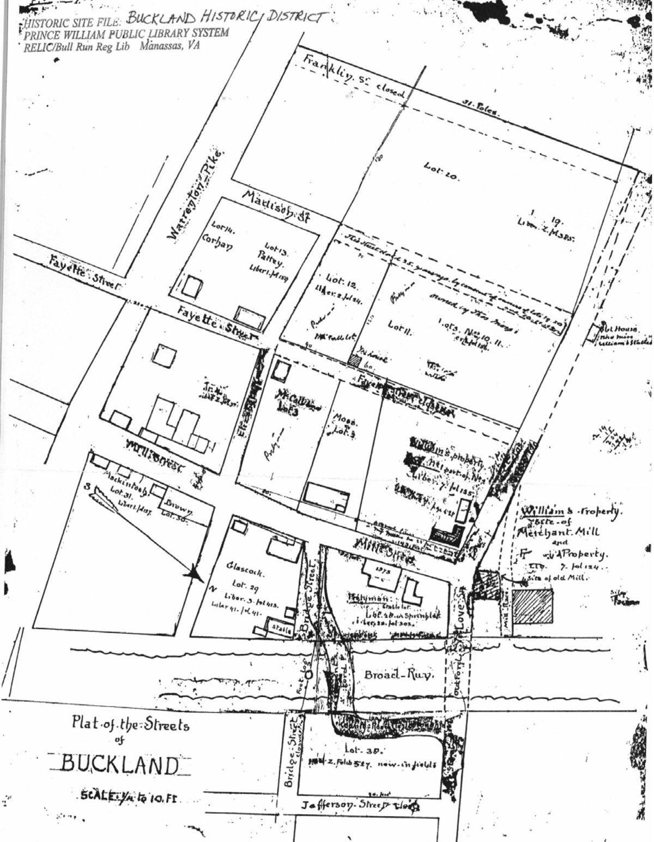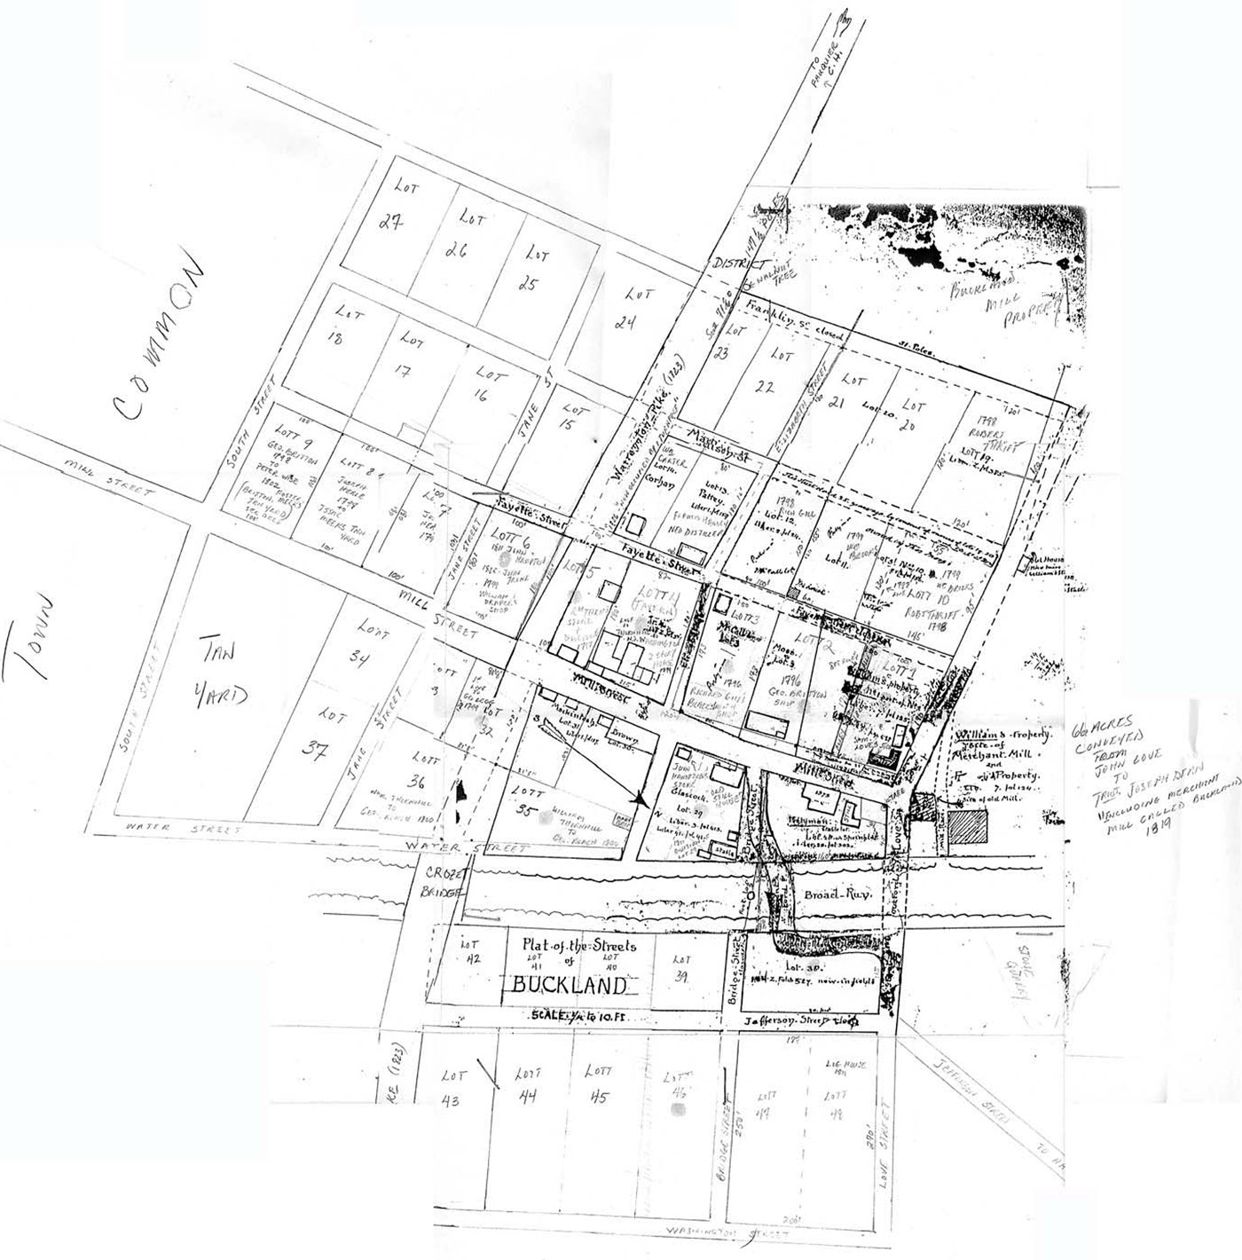
Figure 95: Late 19th-early 20th-century Plat of the Streets of Buckland produced by an unidentified researcher. Note the street names, lot numbers, measurements, building locations, and deed book references recorded on this map. The approximate date of this document is based upon known dates of property owners indicated on the plat. Note direction of north arrow.
Figure 96: David Blake’s late 20th-century extension and annotation of the Plat of the Streets of Buckland. The additional lot numbers and street names are based upon extensive deed research.

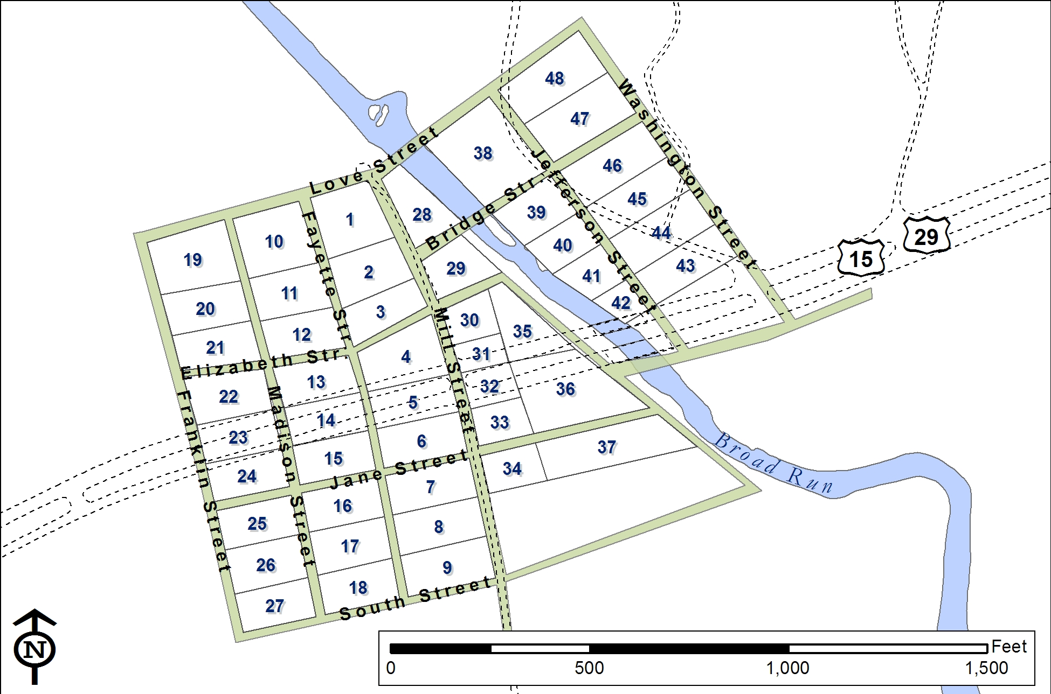
Figure 97: Schematic representation of Buckland’s original 48-lot plan traced from a tentative geo-registration of the Buckland town plan presented by Ridout et al (2005:4). The grid of named streets and numbered lots is believed to be accurate. Dashed lines represent the edges of modern roads as contained in Prince William County’s GIS data layer.

(modern-day Buckland Mill Road/Rt. 684). Following these initial entries are listed pairs of lots (e.g. 18, 27; 17, 26; 16, 25) that in the reconstructed plan lie on opposite sides of Madison Street proceeding from south to north. Correspondences such as these between the patterning of lots in 1798 list and the reconstructed town plan supports the essential accuracy of the reconstruction while also suggesting that the list was compiled with direct reference to the original plan.

While the various reconstructions of the plan of Buckland appear to be generally accurate, they remain schematic and only nominally scaled. The current challenge is to create a fully and accurately scaled plan that is also located as precisely as possible in space, with the ultimate goal of being able to reestablish on the ground the boundaries and orientations of Buckland’s original lots and streets. Doing so requires identifying ground control points or ‘anchors,’ physical landmarks in present-day Buckland that provide direct links to the town’s lots as they were first described in the late-eighteenth and early-nineteenth centuries, typically in deeds recording the sale of individual lots.

Initial comparison of present-day parcel boundaries in and around Buckland, as depicted within Prince William County’s GIS data layer, with the reconstructed town plan indicates some apparent points of potential agreement between past and present land divisions. In-field identification of modern parcel corners and their locational recordation using sub-meter GPS also failed to produce a sufficient number of points that could be linked with confidence to lot corner points described historically.

The reconstructed plan of Buckland presented here is based upon metes and bounds descriptions of individual lots provided in early deeds. Unfortunately, full late-eighteenth or early nineteenth-century boundary descriptions containing both compass bearings and lengths of lot lines are available only for a relatively small minority of the town’s 48 original lots and include Lots 2, 3, 4, 5, and 6 all located along the west side of Mill Street. In two of these cases, (Lots 2 and 3), errors appear to have been made in recording the bearings of the lots’ northern and southern sides. Less specific boundary descriptions containing line lengths and bounding lots and/or streets but only general or vague orientations (i.e. “running easterly…,” “thence southerly…,” “with the line of Lot 31…,” “and with Fayette Street…”) are available for one-third (n. = 16) of all lots, and include Lots 1, 7-13, 19, 28 (part of), 29, 31, 32, 38, 47, and 48. Descriptions of two more lots, Lots 35 and 36, provide one or more shared boundaries with other lots or streets but neither lengths nor orientations of boundaries exist. However, no historic descriptions whatsoever exist for just over half (n. = 26) of Buckland’s original 48 lots (Lots 14-18, 20-28, 30, 33, 34, 37, 39-46) (Figure 98) even if many of these lots receive at least brief acknowledgement in the documentary record. Beginning with those lots described most fully, the following section reviews the available late-eighteenth to early-nineteenth-century metes and bounds descriptions and reconstructs, lot by lot, the original plan of Buckland town. The primary anchor point for this reconstruction is the building in Lot 1 known as John Love’s Store, however the reconstruction begins with Lot 2 immediately to the south.
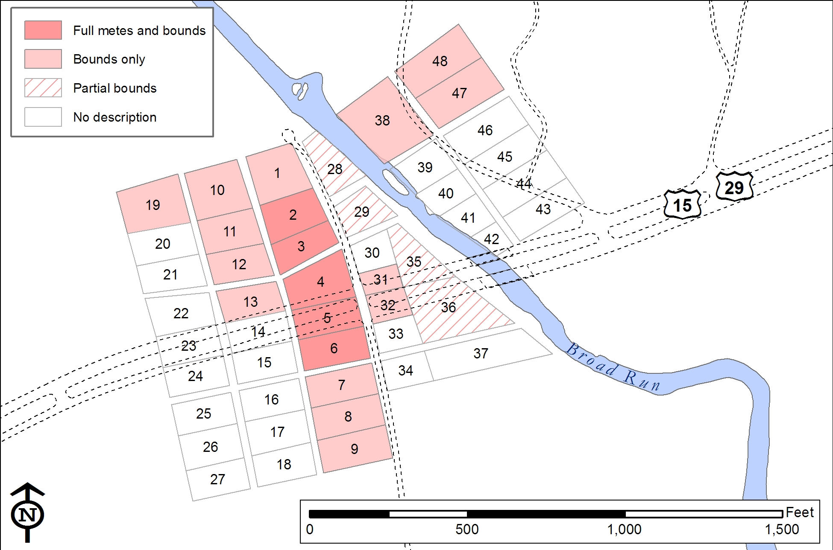
Figure 98: Schematic reconstruction of Buckland town plan illustrating the variable character of available original lot descriptions.

A Note on Magnetic Declination
Bearings of survey lines provided in historic metes and bounds descriptions were determined by magnetic compasses that point to magnetic north rather than to ‘true’ (‘geodetic’) north as defined by the earth’s geographical north pole. Thus, a bearing of North 24° East describes a line oriented 24° east of magnetic north. The difference (measured as an angle) between true north and magnetic north is called magnetic declination or magnetic variation. Magnetic declination varies according to geographical location, however Earth’s magnetic field is constantly changing and therefore magnetic declination also varies through time. Accurately mapping historic metes and bounds requires accounting for change through time in magnetic declination. This project relies upon the U.S. Historic Declination calculator provided by NOAA’s National Geophysical Data Center that uses mathematical models to estimate past declination values for specific times and places. As these values are thought accurate only to within half a degree (30 minutes), in this project no corrections have been applied when the estimated historic declination is less than this value. In the two decades bracketing the beginning of the nineteenth century when many of the available historic metes and bounds descriptions of Buckland lots were recorded, estimated magnetic declination varies between one-fifth and one-third of a degree (12 – 18 minutes) and therefore no corrections have been applied to these earliest bearings.

West of Mill Street (Lots 1-27)
Lot 2: Lot 2 was among those lots already built upon at the time of Buckland’s establishment, and the 1796 deed recording the sale of the lot by John Love to George Britton indicates that Lot 2 fronted on Mill Street to the east and that its northeastern corner was located South 24º East 39 ft from the southeastern corner of Love’s Store House in adjacent Lot 1. In this earliest deed, Lot 2 was described as being 173 ft deep (east to west) and 115 ft 8 inches wide (north to south). In a slightly later deed (1799) in which a 50 ft x 130 ft portion of Lot 2 was sold to James Taylor, the encompassing Lot 2 was described as measuring 180 ft by 115 ft. Metes and bounds are provided for Lot 2 in the original 1796 deed, however when platted as provided (beginning at the lot’s northeast corner and running counterclockwise) the bearings of the northern (N66ºW) and southern (S66ºE) sides appear to be reversed. The bearings of the eastern (N24ºW) and western (S24ºE) roughly parallel the orientation of modern-day Buckland Mill Road and appear to have been properly measured and transcribed. The relationship between the provided northing and easting angles (24º + 66º = 90º) suggests that Lot 2 is rectangular.

Platting of Lot 2 as a rectangle requires beginning the provided sequence at the lot’s northwestern corner (rather than northeastern as indicated in the deed) or by switching the first (north side) and third (south side) bearings in the provided sequence. With these corrections made, the 39-ft distance from the southeast corner of Love’s Store House allows Lot 2 as originally described to be accurately platted in real space (Figure 99).

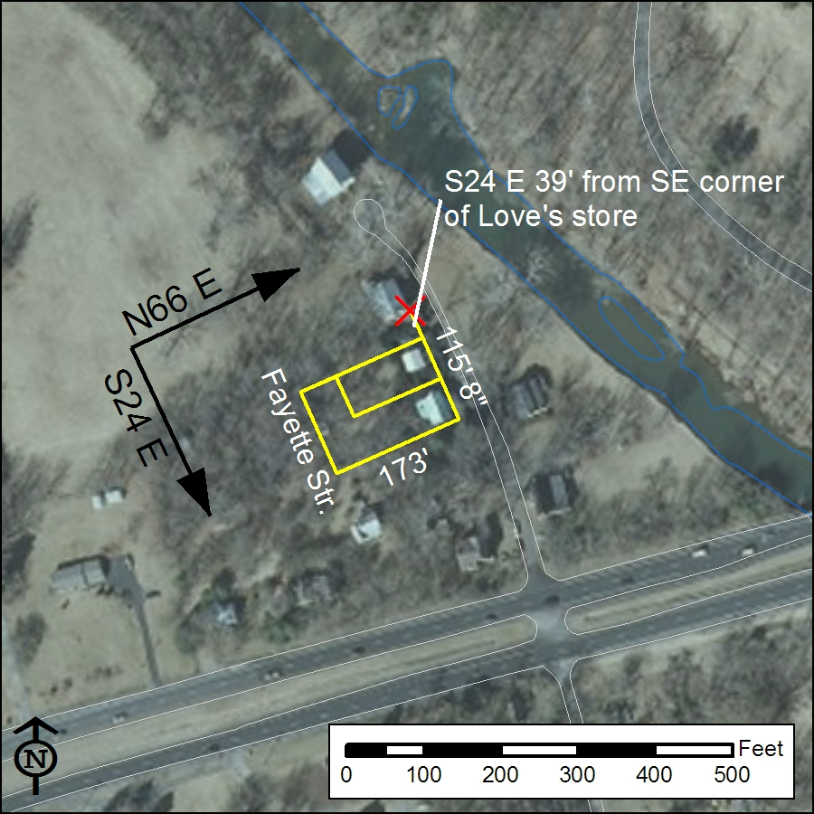
Figure 99: GIS map showing corrected 1796 metes and bounds for Lot 2 (with 1799 subdivision) overlaid on recent aerial photography.

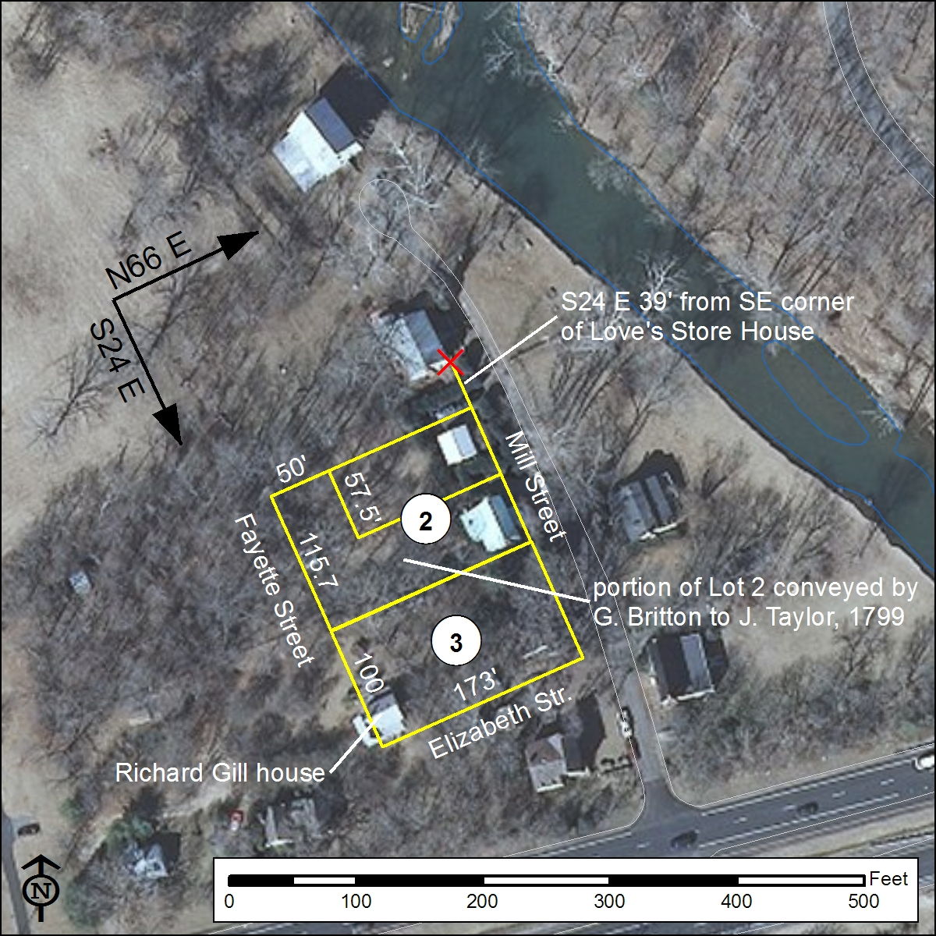
Figure 100: GIS map showing corrected 1796 – 1799 metes and bounds for Lots 2 and 3 overlaid on recent aerial photography. .

Lot 3: Lot 3 also was built on prior to the establishment of Buckland, and a 1796 deed recording the sale of the lot by John Love to Richard Gill describes the property as being located immediately south of Lot 2, and thus also fronting on Mill Street. Orientations for the sides of Lot 3 are identical to (and presented in the same order as) those for Lot 2. While Lot 3 also measures 173 ft in depth (east-west), this lot measures only 100 ft wide (north-south). With the northeastern corner of Lot 3 congruent with the southeastern corner of Lot 2 and correcting the bearings as in Lot 2 to result in a rectangular lot, platting of Lot 3 reveals that the late eighteenth-century portion of the Richard Gill house occupies the extreme southwestern corner of the lot (Figure 100).

Lot 1: Like Lots 2 and 3, Lot 1 also was among those lots already built upon at the time of Buckland’s establishment. Two late eighteenth-century deeds recording its sale are known (Oct. 10, 1798 from John Love to Samuel Love; Sep 2, 1799 from John Love to William Brooks), and both deeds locate the lot at the southwest corner of the intersection of Love Street and Mill Street. The lot’s boundaries are described identically in both deeds, but neither deed provides orientations for its sides. Notable is the fact that the northeast corner of the Lot 1 is described as corresponding to the northeast corner of the “store now occupied by the said Samuel Love” indicating that the structure’s east façade was congruent with the west side of Mill Street while it’s north façade marked the south side of Love Street. Along the south, Lot 1 measured 180 ft and was separated from Lot 2 by an 8-ft-wide alley running between Fayette Street to the west and Mill Street to the east. The south side of Lot 1 clearly paralleled the north side of Lot 2, and thus from Fayette Street ran N66ºE 180 ft. The southeastern corner of Lot 1 was described by the intersection of the 8-ft-wide alley with Mill Street and can be inferred to have been located 31 ft (39 ft – 8 ft) southeast of the southeastern corner of the Love Store/House. While the east side of Lot 1 described the western edge of Mill Street, neither a length or bearing for this side of Lot 1 is provided in the early deeds. The orientation must be that of the Love Store (S24ºE) while the length can be calculated from the width of the building (~45 ft) and the distance from its southeastern corner to the north side of the 8-ft-wide alley (31 ft), thus approximately 76 ft. While the deeds provide lengths for both the northern (190 ft) and western (100 ft) sides of Lot 1 and note that they are bounded by Love Street and Fayette Street, respectively, compass bearings are not provided for either of these two sides. Having inferred the locations of the northeastern and southwestern corners of Lot 1, the north side can be calculated to have run approximately N27ºE and the west side approximately S30ºE. Relative to the boundaries of Lots 2 and 3 to the south, the western side of Lot 1 appears to have been rotated approximately 6º westward (counterclockwise) and the northern side approximately 6º eastward (clockwise). Also implied is a comparable bend in the angle of Fayette Street, suggested also by the variable lengths of the side lot lines of Lots 1, 2, and 3. This reconstruction of the boundaries of Lot 1 is presented graphically in Figure 101, below.

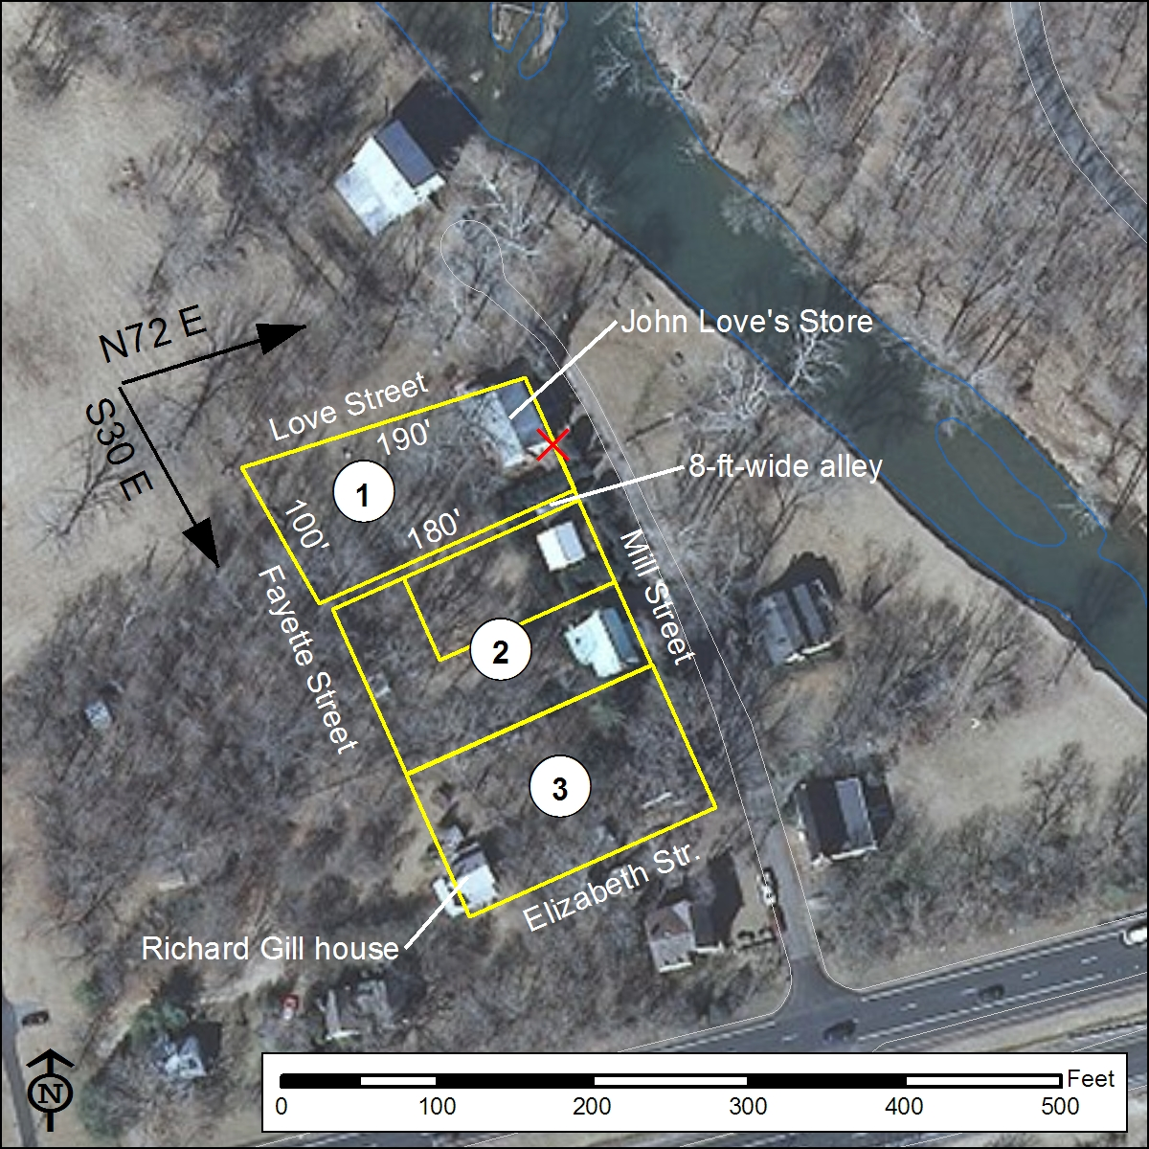
Figure 101: GIS map showing the proposed reconstruction of the boundaries of Lot 1 and overlaid on recent aerial photography. Note the rotations of the western and northern sides of Lot 1 relative to Lots 2 and 3 to the south.

Lot 4: Lot 4 was occupied prior to the establishment of Buckland. Two 1799 deeds recording its sale (first to Charles Thornhill and then to William Brooks) indicate that Lot 4 was bounded by Mill Street to the east, Elizabeth Street to the north, Fayette Street to the west, and Lot 5 to the south. The second of the two 1799 deeds indicates that the northeastern corner of Lot 4 was located 20 ft south of “the South East corner of Richard Gill’s Blacksmith shop” along a line running S12ºE. Although Gill’s blacksmith shop does not survive, here it is assumed to have occupied the extreme southeastern corner of Gill’s Lot No. 3, fronting Mill Street on the east and Fayette Street on the south. The late eighteenth-century description provided of Lot 4 suggests that Fayette Street measured roughly 20 ft in width. Metes and bounds provided for Lot 4 indicate a 12-degree shift in the orientation of Mill Street at the northern end of Lot 4 (from S24º East to S12º East) while the provided dimensions indicate the lot’s necessary non-rectangular shape to accommodate this rotation in the street grid. Along Mill Street, Lot 4 measures 115 ft while to the west along Fayette Street the lot reduces to 82 feet in width. A slightly earlier deed for Lot 5 provides metes and bounds indicating that the east side of Lot 4 along Mill Street measured 120 ft (as opposed to 115 ft). When platted, this slightly longer measurement appears the more accurate and therefore is used in this reconstruction. The first of the two 1799 deeds provides a length of 182 ft for the north side of Lot 4 along Elizabeth Street. While no bearing for this side is provided, it can be assumed to have paralleled the boundary between Lot 3 and Elizabeth Street to the north, thus running S66ºW from Mill Street (Figure 98).

Lot 5: Prior to the establishment of Buckland, Robert Thrift had constructed a store and multiple dwelling houses on Lot 5. The 1797 deed recording John Love’s conveyance of property to Thrift describe the 180 ft by 100 ft Lot 5 as bounded by Mill Street and Fayette Street to the east and west, respectively. The northeastern corner of Lot 5 is given as 140 ft southeast of the southeastern corner of Gill’s blacksmith shop in Lot 3 along a line running S24º East thus, as mentioned, implying a 120-ft eastern width for Lot 4. Orientations provided in the 1797 deed for the eastern (S24ºE), southern (S78ºW), western (N12ºW), and northern (N78ºE) sides indicate that the lot was rectangular and likewise that its bounding streets formed right angles with one another (Figure 102).

Lot 6: William Draper had constructed a shop on Lot 6 prior to the establishment of Buckland. The deed recording conveyance of the property to Draper located the northeastern corner of this lot 240 ft southeast of the southeastern corner of Gill’s blacksmith shop in Lot 3 along a line running S24º East, thus locating the lot immediately south of Lot 5 and between Mill and Fayette Streets. In size and shape, Lot 6 mirrored Lot 5 to the north.

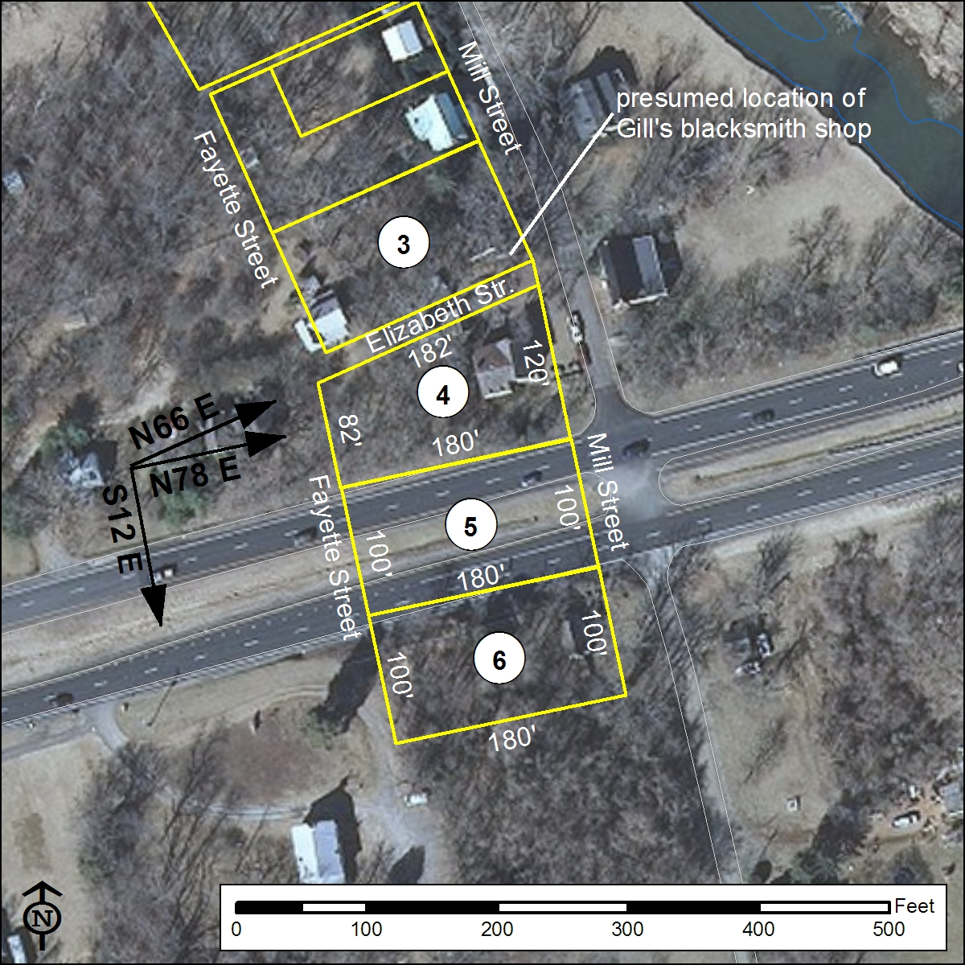
Figure 102: GIS map showing the boundaries of Lots 4, 5, and 6 as platted from historic metes and bounds descriptions and overlaid on recent aerial photography. Note the rotation of this group of lots 12º east of the lots north of Elizabeth Street.

Lot 7 and Lot 8: These two lots initially were sold together by the trustees of the town of Buckland to Joseph Hale in 1798. The deed recording the conveyance indicates that the two lots are bounded by Mill Street to the east and by Fayette Street to the west and that Lot 7 is located immediately north of Lot 8. Lot 7 is bounded to the north by Jane Street, for which no width is provided. Given the sequential numbering of Lots 1 – 6 to the north, it is assumed that Jane Street ran between Lot 6 and Lot 7. Bearings are not provided for the lots’ sides, however both lots are described as measuring 180 ft east-west by 100 ft north-south and it is assumed that Lots 7 and 8 are rectangular and oriented the same as Lots 4 – 6 to the north. In 1799, Hale sold Lot 8 to George Britton, owner of adjacent Lot 9. Britton soon built a house on Lot 8 and developed a tanyard that extended across the adjoining Lot 9. Isaac Meeks apparently acquired both tanyard lots prior to 1810, and the early 19th-century residence still standing in the southwestern corner of Lot 8 is today known as the Isaac Meeks House (Ridout et al. 2005:89-90). The earliest 16 ft x 16 ft part of the house appears to be located wholly within Lot 8 but a later addition apparently extended the structure into Lot 9 (Figure 103).

Lot 9: Lot 9 also measured 100 ft by 180 ft and was sold by the trustees to George Britton in 1798. The deed recording the conveyance describes Lot 9 as being bounded by Lot 8 to the north, by Mill and Fayette Streets to the east and west respectively, and by South Street to the south. Although no lot boundary orientations are provided, it is assumed to have shared that of its neighbors to the north, as presented graphically in Figure 103. This reconstructed configuration of Lots 7, 8, and 9 gains support from the platted boundaries of adjoining Buckland Farm as these were surveyed in 1855.
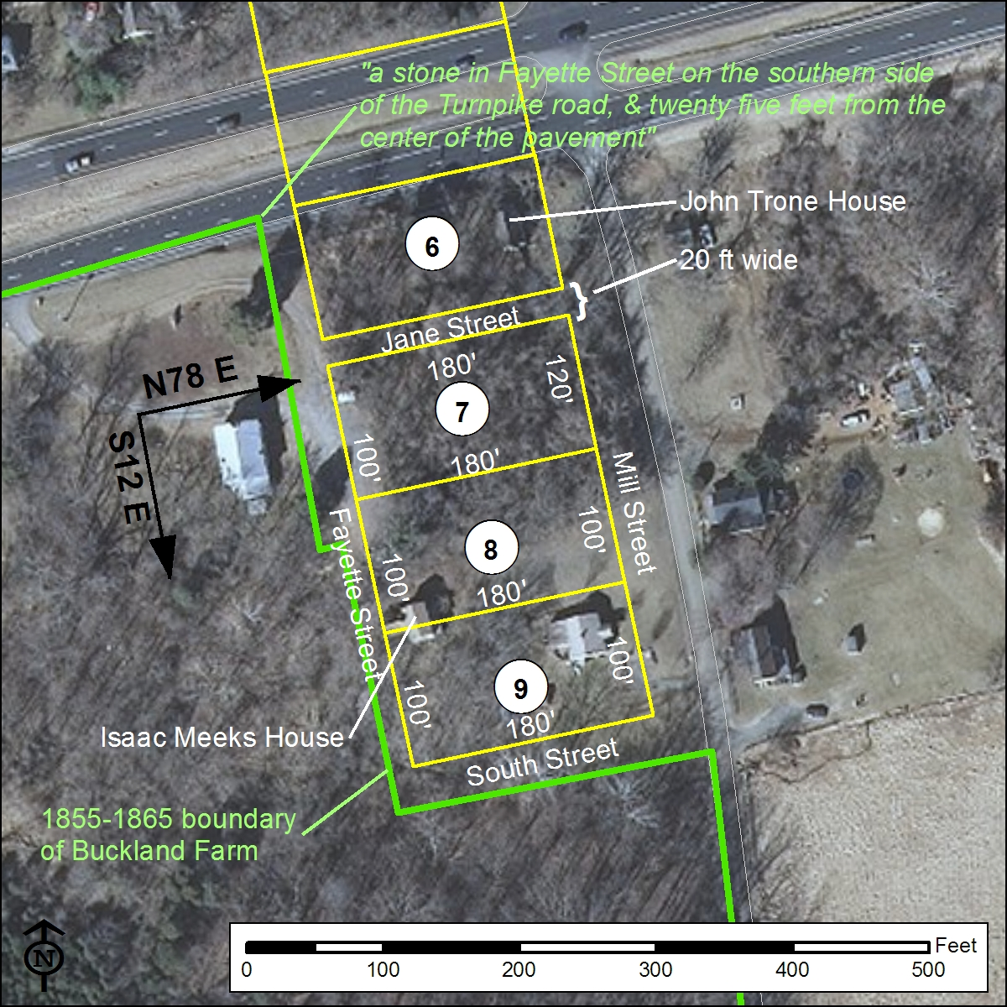
Figure 103: GIS map showing the reconstructed boundaries of Lots 7, 8, and 9 overlaid on recent aerial photography. Boundaries of Buckland Farm ca. 1855-1865 are shown in green and have been rotated 2.1º westward (counterclockwise) to account for historic variation in magnetic declination as estimated by NOAA’s National Geophysical Data Center historic declination calculator (http://www.ngdc.noaa.gov/geomag-web/#ushistoric).

Lots 10, 11, 12: Late eighteenth to early nineteenth-century deeds exist for Lots 10, 11, and 12 and while lengths of lot lines and bounding features are provided, no original orientations are given for any of the sides of these three lots. Furthermore, none of the lots appear to be rectangular. Although these three lots can be confidently located immediately south of Love Street between Fayette and Madison Streets, precise reconstruction of each lot’s original configuration remains elusive given the documentary evidence available.

Lot 10 was originally sold (together with adjoining Lot 19, see below) by the Buckland trustees to Robert Thrift in 1798. In the deed of conveyance, Lot 10 is described as bounded by Fayette Street (east), Madison Street (west), and Lot 11 (south). The lot’s northern boundary is given as Mill Street but this clearly is mistaken and should have been Love Street. The lot is irregularly shaped, measuring 145 ft along its eastern side, 130 ft along the south and 155 ft along the west. The dimension of the lot’s north side is not provided in the 1798 deed but is given as 95 ft (along the properly named Love Street) in a 1799 deed recording the sale of Lots 10 together with Lot 11. No compass bearings are provided in either of the two deeds to indicate the orientation of the lot, however the eastern side along Fayette Street can be assumed to share that street’s orientation as determined by the west side of Lot 1 (from Love Street, S30ºE). The east side of adjoining Lot 11 is given as 100 ft however the orientation is assumed to shift 6º eastward (clockwise), mirroring the western boundary of Lots 2 and 3 to the east. The length of the east side of Lot 12 is provided in a 1798 deed 100 ft “or thereabouts.” The combined frontage along Fayette Street of Lots 10, 11, and 12 measures approximately 345 ft, or roughly 30 ft greater than the combined frontage of Lots 1, 2, and 3 on the eastern side of this street. The combined frontage of Lots 10, 11, and 12 to the west along Madison Street cannot be determined as only measurements for the western side of Lot 10 (155 ft) and Lot 11 (100 ft) is provided. The shared boundary between Lots 10 and 11 measures 130 ft, while the shared boundary between Lots 11 and 12 is given alternately as “about” 150 or 155 ft. No measurement for the south side of Lot 12 along Elizabeth Street is provided in the available deeds.

Further complicating the accurate platting of Lots 10, 11, and 12 is the fact that nowhere in the deed record are the intended widths of the streets provided with the exception of Elizabeth Street which appears to have been 20 ft. Following the example of Elizabeth Street, the other east-west cross streets within Buckland are assigned widths of 20 ft. The north-south oriented Fayette and Madison Streets are assigned widths of 30 ft. As here reconstructed and illustrated in Figure 100, the shared boundary between Lots 10 and 11 is roughly 11 ft longer that described in the deed, while the shared boundary between Lots 11 and 12 is 7-12 ft longer than the values provided.

Lots 13, 14, and 15: According to the July 7, 1798 list of lots sold by the Buckland trustees, W.J. Washington purchased Lot 13 however no deed recording the conveyance has been discovered. In 1800, John Love sold Lot 13 to Francis Hawley, and the deed places the lot immediately south of Elizabeth Street between Madison (west) and Fayette (east) Streets. No bearings for the side lot lines are provided, however the deed records that the lot measures 180 ft east-west and 80 ft north-south, indicating that the lot was at least a parallelogram. Here, it is assumed that the sides

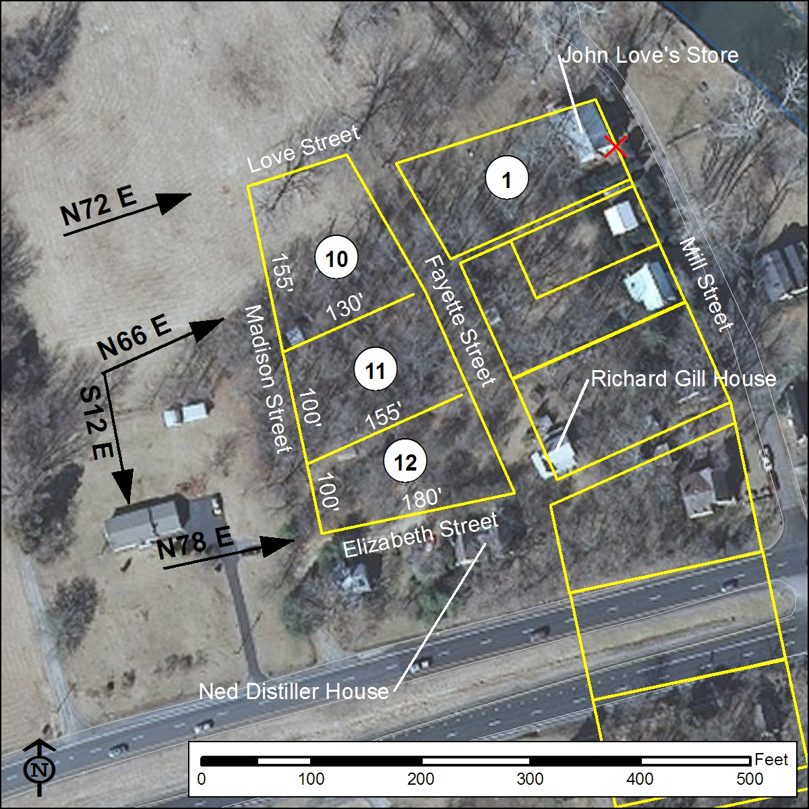
Figure 104: GIS map showing the boundaries of Lots 10, 11, and 12 as reconstructed from historic metes and bounds descriptions and overlaid on recent aerial photography.

of Lot 13 share the same orientations as the rectangular lots east of Fayette Street and south of Elizabeth Street (Figure 105).

The trustees of the town of Buckland sold Lot 14 to William Carter according to the July 7, 1798 list, however no deed recording the conveyance has been found. In 1826, Josiah Watson conveyed Lot 14 to John Robinson. No metes and bounds are provided in the deed of conveyance, however the deed does record that the Fauquier & Alexandria Turnpike then occupied part of the lot, indicating that Lot 14 almost certainly was located immediately south of Lot 13. As detailed below, construction of the turnpike impinged upon approximately half of Lot 14. Metes and bounds descriptions of Lot 14 have not been discovered in later deeds. In 1854, Lot 14 was purchased by Oscar Pattie. The reconstruction presented here in Figure 105 assumes the lot to be rectangular and to share the size (100 ft x 180) and orientation of lots located to the east between Fayette and Mill Streets.

Lot 15 was among those lots purchased by John Love and appears to have not been resold but to have remained a part of Love’s Buckland Farm. Based on the established grid of numbered lots to the east and north, Lot 15 is assumed to have been located immediately north of Jane Street between Madison (west) and Fayette (east) Streets and to have measured 100 ft x 180 ft. Possibly, construction of the Fauquier & Alexandria Turnpike in the early nineteenth century may have impinged upon the northern edge of Lot 15. Lot 15 comprised a little less than half of the one-acre tract sold by Buckland Farm’s owner Hugh Hite in 1856 and that now houses the Buckland St. Mark’s Methodist Church (Figure 105).

Lots 16, 17, and 18: These three lots were all purchased by John Love and apparently were never resold, and thus effectively remained part of Love’s Buckland Farm through at least the middle of the nineteenth century. Metes and bounds descriptions for these three lots have not been discovered. The reconstruction presented here in Figure 105 assumes that in shape, size, and orientation these three lots are identical to those east of Mill Street. According to this reconstruction, Lot 16 made up roughly half of the one-acre tract sold by Hugh Hite in 1856 to the trustees of Buckland’s St. Mark’s Church.
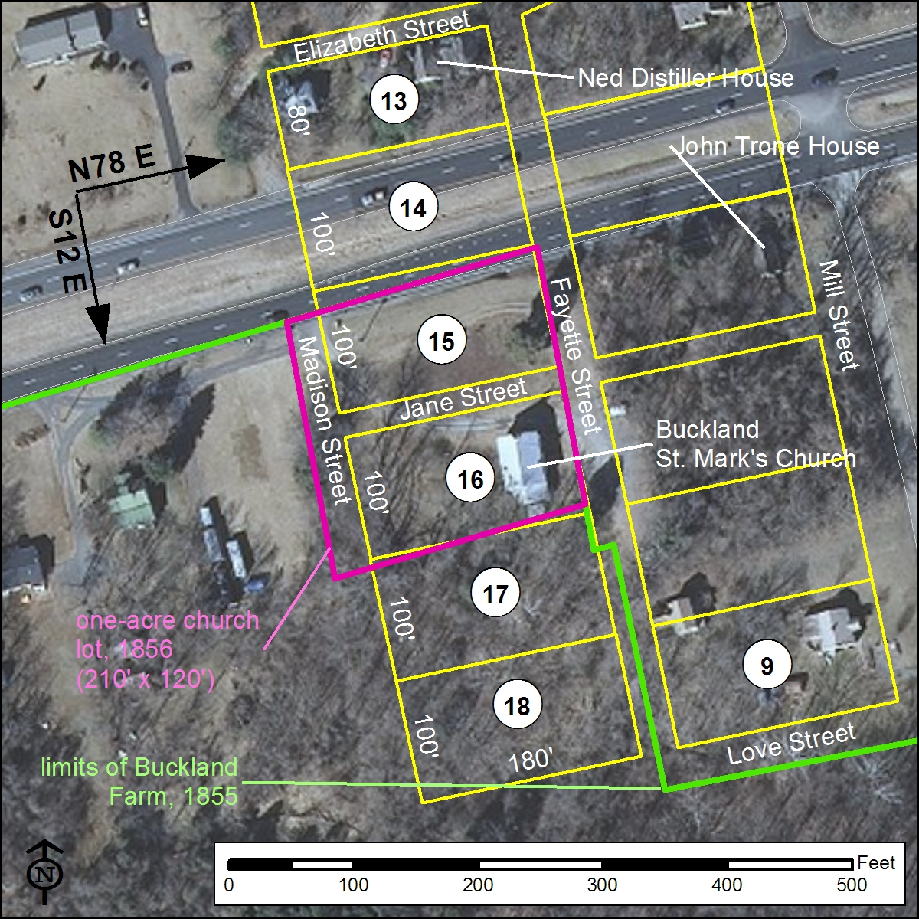
Figure 105: GIS map showing the boundaries of Lots 13 – 18 as reconstructed from historic metes and bounds descriptions and overlaid on recent aerial photography.

Lot 19: On July 15, 1798, Robert Thrift purchased Lot 19 (together with Lot 10) from Buckland’s trustees. According to the deed recording the conveyance, Lot 19 was bounded by Madison Street to the east and by Franklin Street to the west. As with the accompanying description of Lot 10, the northern boundary was mistakenly provided as Mill Street instead of Love Street. The lot was described as measuring 180 ft (east-west) by 120 ft (north-south) however no orientations of the lot’s sides were provided. The orientation of Madison Street as provided by the reconstructed western sides of Lots 10 - 13 provides an orientation of S12ºE for the east side of Lot 19. An 1819 deed conveying a property adjoining to the west and running along Franklin Street provides the very similar orientation of S15.5ºE (S15.3ºE when corrected for historic magnetic declination) for Franklin Street along the opposite (west) side of Lot 19. An 1895 survey of the same property line has a corrected orientation of S13ºE. In this reconstruction, Lot 19 is assumed to have been rectangular with parallel northern and southern boundaries and that its original north-south orientation was the same as Mill Street south of Elizabeth Street (S12ºE) (Figure 102). Madison Street, like Fayette Street, is assumed to have a width of 30 ft, thus suggesting that Franklin Street in the original Buckland plan was 60 ft wide.

Lots 20, 21: Lots 20 and 21 were purchased by John Love and apparently were never resold, and thus effectively remained part of Love’s Buckland Farm. Metes and bounds descriptions for these two lots have not been discovered. This reconstruction assumes Lot 20 and 21 were located immediately south of Lot 19 and that in shape, size, and orientation Lots 20 and 21 both measured 180 ft east-west and 100 ft north-south. Elizabeth Street, running N66ºE from Franklin Street to Madison Street, bounded the south side of Lot 21 (Figure 106).

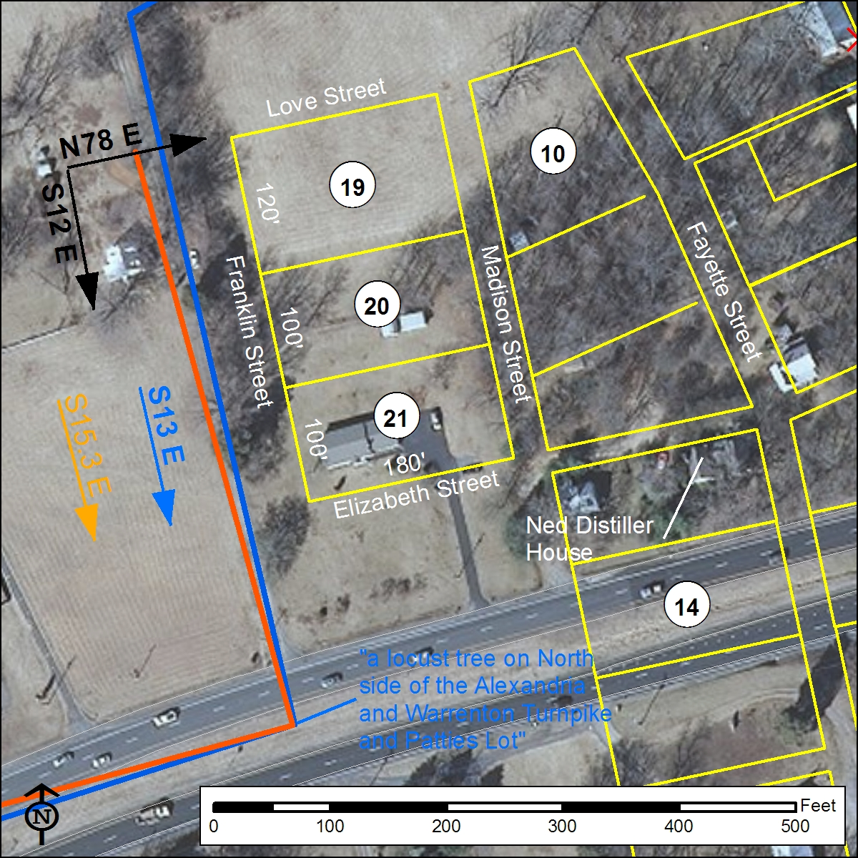
Figure 106: GIS map showing the boundaries of Lots 19, 20, and 21 as reconstructed from historic metes and bounds descriptions and overlaid on recent aerial photography. The north-south orientation (S12ºE) is very similar to two later 19th-century surveys of a property line running along the west side of Franklin Street.

Lots 22, 23, and 24: These three lots all were purchased from the town trustees by John Love in 1798 and appear to have remained part of Love’s Buckland Farm. No boundary descriptions or orientations for any of these three lots are known. Based on the grid of numbered lots established by better described lots, this reconstruction places Lots 22 - 24 immediately south of Elizabeth Street between Madison (east) and Franklin (west) Streets and assumes that the sizes and configuration of the lots mirror that of Lots 13 - 15 on the opposite (east) side of Madison Street. Thus, Lot 22 is believed to have measured 80 ft by 180 ft while Lots 23 and 24 measured 100 ft by 180 ft. Lot 24 would have been bounded by Jane Street to the south (Figure 107).

Lots 25, 26, and 27: These three lots were purchased by John Love and apparently were never resold, and thus effectively remained part of Love’s Buckland Farm. Metes and bounds descriptions for these lots have not been discovered. Based on the grid of numbered lots established by better described lots, this reconstruction places these three lots immediately south of Jane Street between Madison (east) and Franklin (west) Streets and assumes that the sizes and configuration of these lots mirror that of Lots 16 - 18 on the opposite (east) side of Madison Street. Thus, all three lots measured 100 ft by 180 ft, with the southernmost lot in the group (Lot 27) being bounded by South Street to the south (Figure 107).

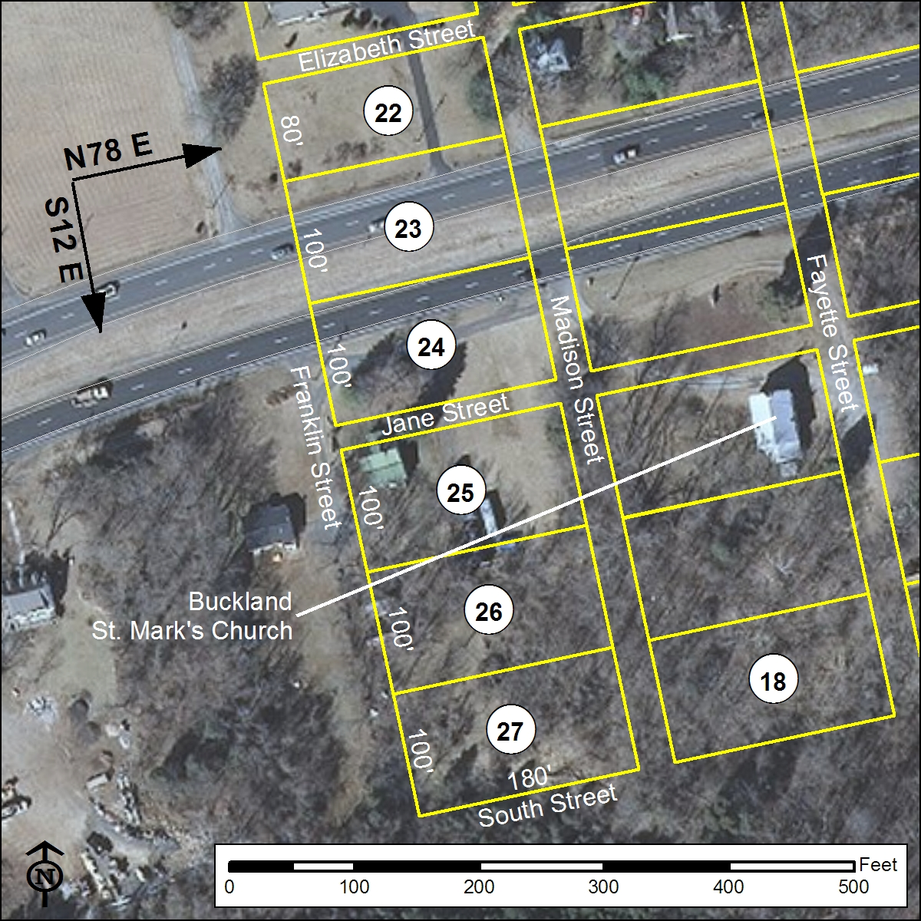
Figure 107: GIS map showing the proposed boundaries of Lots 22 - 27overlaid on recent aerial photography.

Between Mill Street and Broad Run (Lots 28-37)
Lot 28: According to the July 7, 1798 list of lot sold by the trustees of the town of Buckland, Lot 28 was purchased by John Love. In October 1798, John Love sold Samuel Love Lot 1 together with a “part of lot No. 28 lying on Bridge and Mill streets.” The deed recording this conveyance describes the portion of Lot 28 as being located between Mill Street and Broad Run and as roughly “L”-shaped with its southern border defined by Bridge Street, which ran from Mill Street in the west presumably across Broad Run. Love sold this portion of Lot 28 one year later to John Taylor, with the property being described in identical terms. In 1800, in order to secure debts, John Love transferred ownership of multiple lots, among which was included the remaining portion of Lot 28, to the trio of Buckland trustees John Taylor, Josiah Watson, and William Brooks. In 1811, John Taylor signed a deed acknowledging that John Love’s debts had been paid and that he, Taylor, released his interest in the Buckland lots transferred by Love in 1800. This deed releasing Love also references an agreement between John Love and Josiah Watson whereby the two men (Love and Watson) divided ownership of the mortgaged Buckland lots between them. The same year (1811) that John Taylor released John Love of his debts, Taylor sold to Josiah Watson the L-shaped portion of Lot 28 fronting on Bridge Street that he had purchased from Samuel Love in 1799. Although this agreement dividing Buckland properties between John Love and Josiah Watson referenced in Taylor’s 1811 deed of release has not been discovered, available evidence suggests that under its terms Josiah Watson acquired ownership of the remainder of Lot 28, thus bringing the entirety of Lot 28 into his possession. Between 1824 and 1851, Prince William County tax records list Josiah Watson (or his estate) as the owner of Lot 28. Unfortunately, apart from the two late eighteenth-century deeds conveying the L-shaped portion of Lot 28 fronting on Bridge Street, no further deeds in the chain of title of this lot are known until a 1902 deed recording the conveyance of a 0.44-acre lot east of Mill Street and north of Bridge Street from Jennie and William Prettyman to I.R. Wolverton. Full metes and bounds for the parcel are provided in this deed, and are mapped as given (with the appropriate 4.433º westward, counterclockwise rotation, to account for historic variation in magnetic declination) in Figure 108. The orientation provided in this 1902 deed for the north side of Bridge Street (N55ºE) is nearly identical to that provided for the south side of Bridge Street (N54¾ºE) 11 years earlier in 1891 in a deed conveying Lot 29. Possibly, the orientation of Bridge Street as recorded in 1891-1902 had changed since the original late eighteenth-century town plan of Buckland and in the original town plan Bridge Street shared an axis with the early nineteenth-century Deerlick Cottage in neighboring Lot 29.

Lot 29: According to the July 7, 1798 list of sales of lots by Buckland’s trustees, Lot 29 was among the group of lots not sold because of having already been built on. John Love apparently retained ownership of the property as the following year in 1799 he sold a 38-ft wide portion of Lot 29 fronting on Bridge Street to the north to Francis Hawley. The deed recording the conveyance describes the property as bordering the south side of Bridge Street between Mill Street on the west and Broad Run on the east and containing Hawley’s stables, however no orientations for the property’s boundaries are provided. Roughly one year later, in March 1800, Francis Hawley sold the 38-ft-wide portion of Lot 29 to John Taylor who, as discussed above, already owned a portion of Lot 28 on the opposite (north) side of Bridge Street. The 1800 deed conveying the portion of Lot 29 from Hawley to Taylor provides no further boundary definitions but does reference Taylor’s stable on the property. In 1801, county tax records indicate that Taylor operated a still on the property. Taylor appears to have sold this northern portion of Lot 29 between 1806 and 1810. By November 1811, ownership of the property had passed to Samuel Hudson who conveyed the partial lot, further described as the site of John Hampton’s store, to William Brooks. Ridout et al. date the extant building on Lot 29, Deerlick Cottage, to this period. Several months later in February 1812, Brooks acquired the remainder of Lot 29, described in the deed as “where the old still house stood,” from John Love. Unfortunately, the deed conveying this southern portion of Lot 29 to Brooks in 1812 contains no metes and bounds description of the property. No further deeds in the chain of title of Lot 29 are known until an 1870 deed in which the property, described as containing “one half acre more or less” and bounded by “Main Street” on the west and by an unnamed street running along Broad Run on the east and by unnamed streets on the north and south, was conveyed by Miranda Chappell to Orlando J. Glasscock. Two decades later in 1891, Lassie Glasscock paid delinquent taxes owned on the property and the deed recording this payment and transfer of ownership contains a full metes and bounds description of the half-acre property. These late nineteenth-century boundaries of Lot 29 are mapped (with the appropriate 3.77o westward (counterclockwise) rotation to account for historic variation in magnetic declination) in Figure 108.
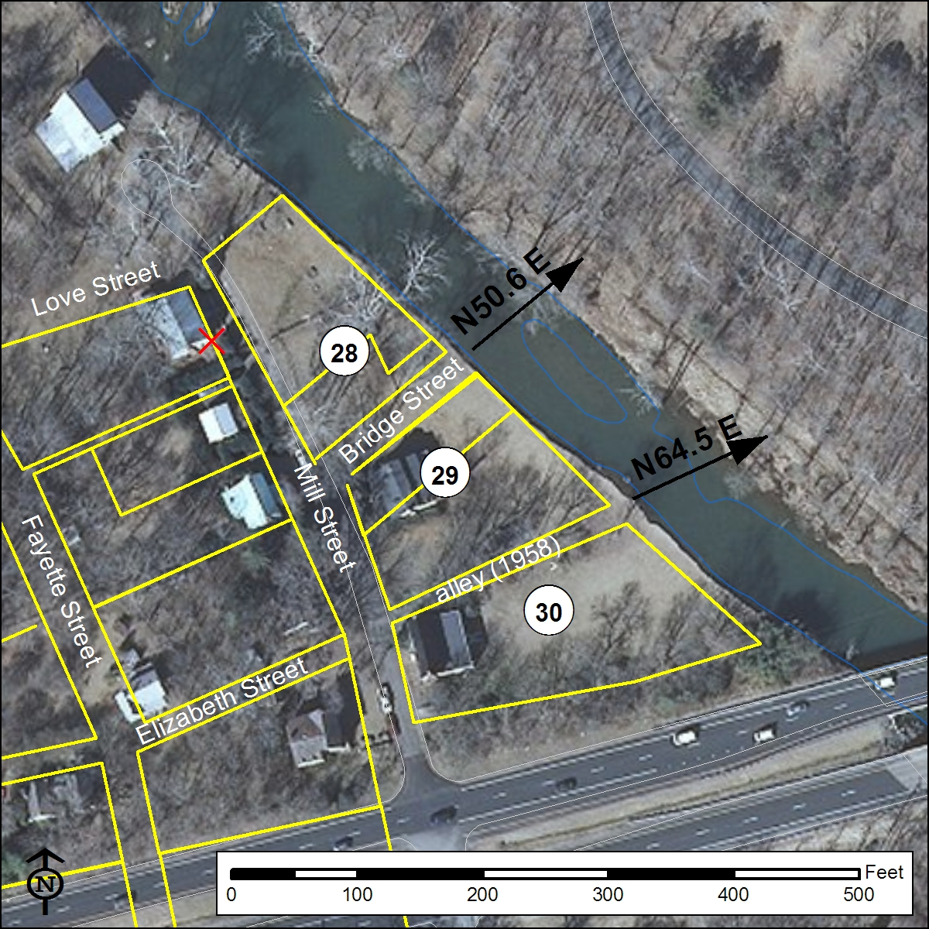
Figure 108: GIS map showing the proposed boundaries of Lots 28 – 30 as platted from late 19th- mid-20th-century metes and bounds and overlaid on recent aerial photography.

Lot 30: Lot 30 was among those lots sold by the trustees of the town of Buckland to John Love July 7, 1798. The property is not among the list of Buckland lots mortgaged by John Love in 1800, suggesting that Love had sold the property however no such deed of conveyance is known. In 1828, Lot 30 was sold by Henry Brooks to William Conner, with the deed providing the additional detail that Henry Brooks acquired the property in 1821 from Josiah Watson. William Conner sold Lot 30 to Edward Robinson in 1832. In 1858, Lot 30 was conveyed to Mary and Eliza Watson by Eppa Hunton. Robert and Ann Watson sold Lot 30 in 1874 to Henry Kerfoot and three years later Kerfoot sold the lot to John B. Hunton. Unfortunately, none of the late eighteenth to early nineteenth-century deeds for Lot 30 contain metes and bounds descriptions of the property, however sufficient information is provided about the owners of adjacent lots to indicate that Lot 30 lies between Lot 29 to the north and Lot 31 to the south. In 1958, a deed conveying a 0.58-acre property from E. Wieneke to N. H. Roberts provides full metes and bounds descriptions of a lot lying between Mill [Main] Street and Broad Run. In this mid-twentieth-century description, an alley of unknown width forms the northern border of Lot 30, while a kink in the lot’s southern side reflects conveyance of small portion of the parcel to the State of Virginia for highway construction/right-of-way. In Figure 108, this property is mapped as described in the 1958 deed (with the appropriate 6.47º westward (counterclockwise) rotation to account for historic variation in magnetic declination). However as discussed in more detail below, by the middle of the 20th it is believed that Lot 30 had subsumed original Buckland town Lot 34.

Lot 31: Lot 31 was among the large group of lots purchased by John Love from the trustees of Buckland town July 7, 1798. In 1800, Love sold Lot 31 to Britton Saunders and the deed recording the conveyance described the lot as measuring 120 ft (east-west) by 81.67 ft (north-south) and bounded by Mill Street on the west and by Lot 30 (north), Lot 35 (east), and Lot 32 (south). No orientations for the boundaries of the lot are provided in the deed. No further descriptions of the boundaries of Lot 31 are known in the chain of title for this property. In Figure 109, Lot 31 is platted as a rectangle with its north-south axis (S12ºE) defined by the orientation of Mill Street and the lots on its opposite side.

Lot 32: Lot 32 was among those lots that had been built on prior to the establishment of the town of Buckland. A 1799 deed recording the conveyance of Lot 32 by John Love to George Legg describes the lot as being located immediately south of and sharing the same dimensions as Lot 31. Lot 31 is further described as being bounded by Lot 33 to the south and Lot 36 to the west. George Legg sold Lot 32 to Robert Ware in 1805, however no description of the property is contained in the deed. It is unclear for how long Ware owned the property or how he disposed of it, however in 1819 Lot 32 was sold by John Love to Edward Robinson who paid taxes on the lot from 1820 until his death around 1844. John Trone, who also owned nearby Lot 6 on the opposite side of Mill Street paid taxes on the property between 1851 and 1865. In 1866, Trone sold Lot 32, described as containing “an old Blacksmith Shop” and tools to Rufus Fairbanks. The deed conveying the property from Trone to Fairbanks also notes that Lot 32 is bounded to the south by the Fauquier and Alexandria Turnpike. In 1875, Fairbanks sold Lot 32 to John Thornberry and thirteen years later Thornberry sold the property to James W. Hunton, however no additional description of the lot is provided in these deeds. In Figure 109, Lot 32 is platted as a originally described in 1799 and sharing a north-south orientation with the lots on the opposite side of Mill Street.

Lot 33: Lot 33 was among those lots purchased by John Love from the Buckland trustees in 1798, however no description of the property was provided. As mentioned above, a 1799 deed places Lot 33 immediately to the south of Lot 32, however no further description of the lot has been discovered. As mapped in Figure 109, Lot 33 is assumed to share the same dimension and orientation as Lots 32 and 31 to the north. Lot 33 was among the large group of Buckland lots mortgaged by John Love in 1800 to John Taylor, Josiah Watson, and William Brooks. Available evidence suggests that ownership of Lot 33 passed to Josiah Watson as part of an agreement between Watson and John Love whereby Love’s Buckland town properties were divided between them. Metes and bounds of a 36-acre tract of land known as “old Mr. Watson’s lot” sold by Andrew J. Watson to Thomas Smith in 1829 indicate that this property was located between Mill Street and Broad Run and that it was bounded to the north by the Fauquier and Alexandria Turnpike. If the placement of Lot 33 shown in Figure 109 is correct, the lot must have been subsumed within “old Mr. Watson’s lot.” The deed recording the 1829 sale of “old Mr. Watson’s lot” further notes that Andrew J. Watson acquired the property from Josiah Watson in 1825.

Lot 34: Lot 34 was among the lots purchased by John Love from the Buckland trustees in 1798, however no description of the property was provided and no further deeds recording the sale of Lot 34 have been discovered. Land tax records for Prince William County indicate that William E. Hunton’s estate paid tax on this lot along with nearby Lots 35 and 36 between 1851 and 1877. Placement of Lot 34 in Figure 109 assumes an as yet undocumented consolidation of this lot with Lot 30 as that lot was described in by metes and bounds in 1958.

Lots 35 and 36: These two lots were among the large group of lots purchased by John Love from the trustees of Buckland town in July 1798. The following year in 1799, Love sold Lots 36 and 36 to William Thornhill and the deed recording the sale described the lots as being “situated on Water Street” however neither dimensions or orientations for the lots were provided. As mentioned above, roughly contemporaneous deeds recording the sale of Lots 31 and 32 indicate that Lot 35 was bounded to the west by Lot 31 and that immediately west of Lot 36 was Lot 32. As mapped in Figure 109, the widths of Lots 35 and 36 are assumed identical to that of Lots 31 and 32 to the west (81.67 ft) and to share the same orientation. William Thornhill sold Lots 35 and 36 to George Roach in 1800, but again the lots were described only as located on Water Street. As discussed in more detail below, construction of the Fauquier and Alexandria Turnpike in 1808 likely took at least half of Lot 36. Although it remains unclear how he came to reacquire the property, in 1825 John Love sold a parcel to William Hunton that, on the basis of the cursory boundary description provided, appears to have contained Lot 35 as well as the northern half of Lot 36 as these two original lots are mapped in Figure 109. The deed conveying the property from Love to Hunton references no lot number but does describe the parcel as bounded to the south by the Turnpike Road and to the east by an “an alley to the town as required by the Plat of it [Buckland town]” while also noting the presence of a house in the northwestern corner of the parcel “now occupied by Mary Brent, a woman of color.” As mentioned, William Hunton’s estate paid taxes on Lots 35 and 36 (along with Lot 34) between 1851 and 1877. Further details in the title chain for these properties remain unknown and no additional descriptions of Lots 35 and 36 have been discovered.

Lot 37: Lot 37 was among those lots purchased by John Love from the Buckland trustees in 1798, however no description of the property was provided. This lot was also among the group of lots mortgaged by Love in 1800 to John Taylor, Josiah Watson, and William Brooks to secure a debt. As with Lot 33, which in this reconstruction borders Lot 37 to the west, Lot 37 drops out of county records after its listing in the 1820 land tax book and evidence suggests that it was among those town lots acquired by Josiah Watson via an agreement with his father-in-law John Love. By 1829, lots 33 and 37 had been incorporated as part of “old Mr. Watson’s lot” located south of the turnpike between Mill Street and Broad Run and sold by Andrew J. Watson to Thomas Smith. In the reconstruction presented in Figure 109, Water Street is assumed to have continued south from Lots 35 and 36. In the original town plan, Jane Street may have bounded Lot 37 and Lot 33 to the south. It is also possible that South Street originally continued east across Mill Street to Broad Run. In this scenario, Lots 33 and 37 may extend all the way south to South Street and thus were originally much larger than their depiction in Figure 109. Alternately, the area between Lots 33 and 37 and South Street may have been occupied by an unnumbered tract that served as a town common (Figure 113), which is how much of this area south of the turnpike and east of Mill Street was used for at least part of the earlier nineteenth century.

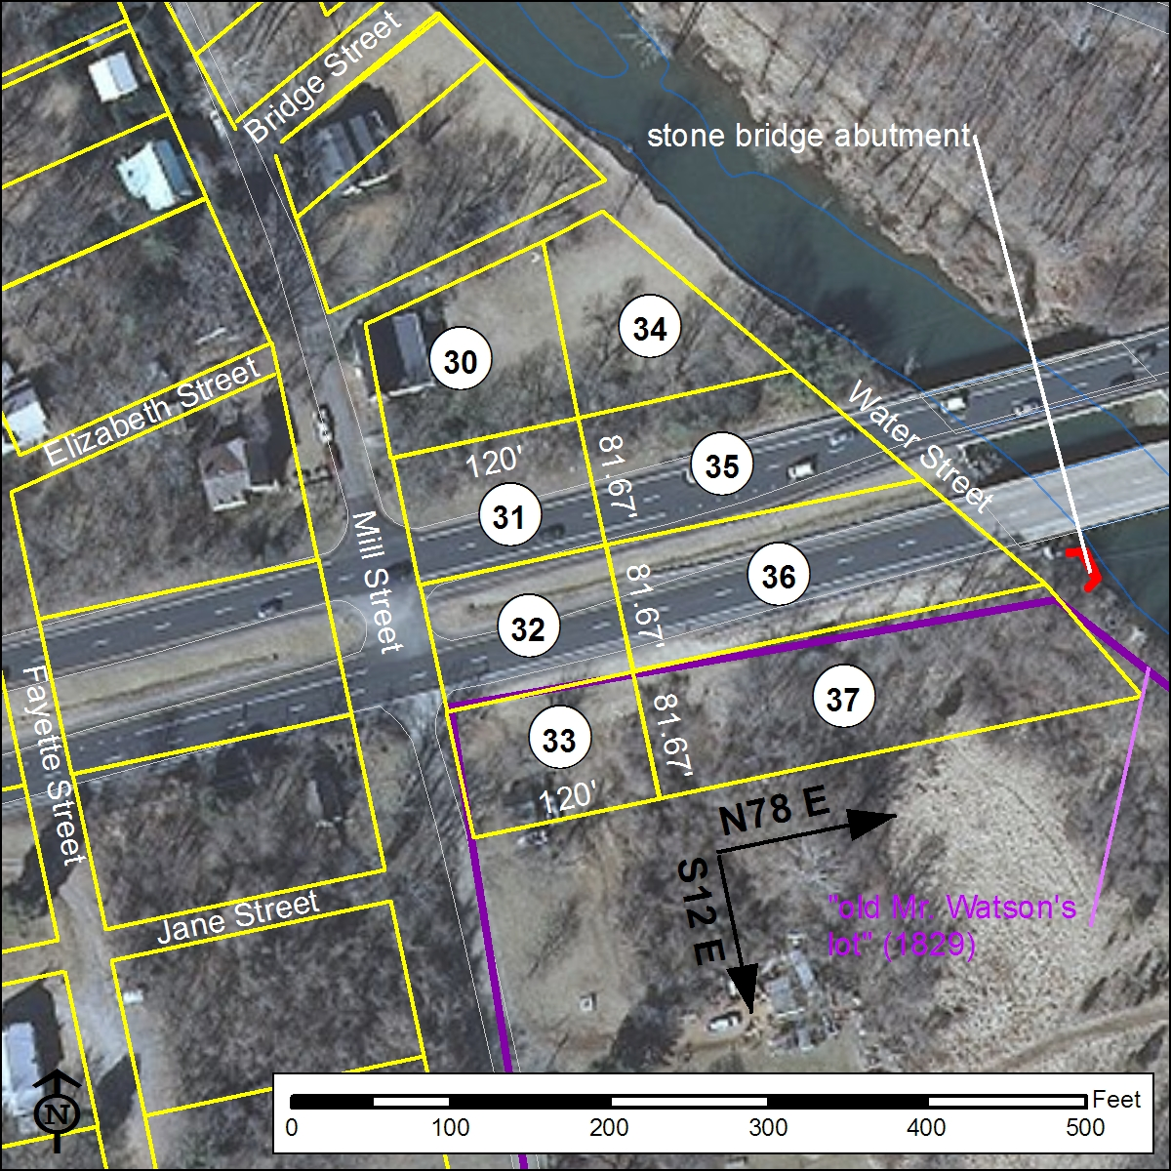

Figure 109: GIS map showing the proposed boundaries of Lots 30 – 37 overlaid on recent aerial photography. Note the division of Lot 30 as mapped in Figure 14 to accommodate Lot 34.

Close consideration of the late nineteenth to early twentieth-century boundaries of Lots 28 and 29 as mapped in Figure 108 above suggests that by this date the orientation of Bridge Street may well have changed since the late eighteenth-century establishment of Buckland. The late-nineteenth to turn-of-the-twentieth-century map of Buckland (Figure 95, above) suggests as much, showing both a northward-trending street that crosses Broad Run at a ford as well as the apparently earlier limits of Bridge Street oriented more nearly perpendicular to the north façade of Deerlick Cottage. In point of fact, assuming that the late nineteenth-century boundaries of Lot 29 as mapped in Figure 108 correspond closely to the lot’s limits in the original late 18th-century plan runs up against the problem that the 38-ft-wide portion of the lot along the south side of Bridge Street that was parceled out in 1799 seems barely sufficient to contain Deerlick Cottage. An alternate reconstruction, and the one preferred here, reorients Bridge Street such that it runs (N66ºE) parallel to the north façade of Deerlick Cottage and intersects Mill Street at a right angle (Figure 106). In Figure 110, Bridge Street is depicted with a width of 30 feet, Mill Street has been widened to 60 feet, and the “alley” referenced in the 1958 deed running between Lots 29 and 30 has been reconfigured slightly so that it more clearly represents a continuation of 20-ft-wide Elizabeth Street.
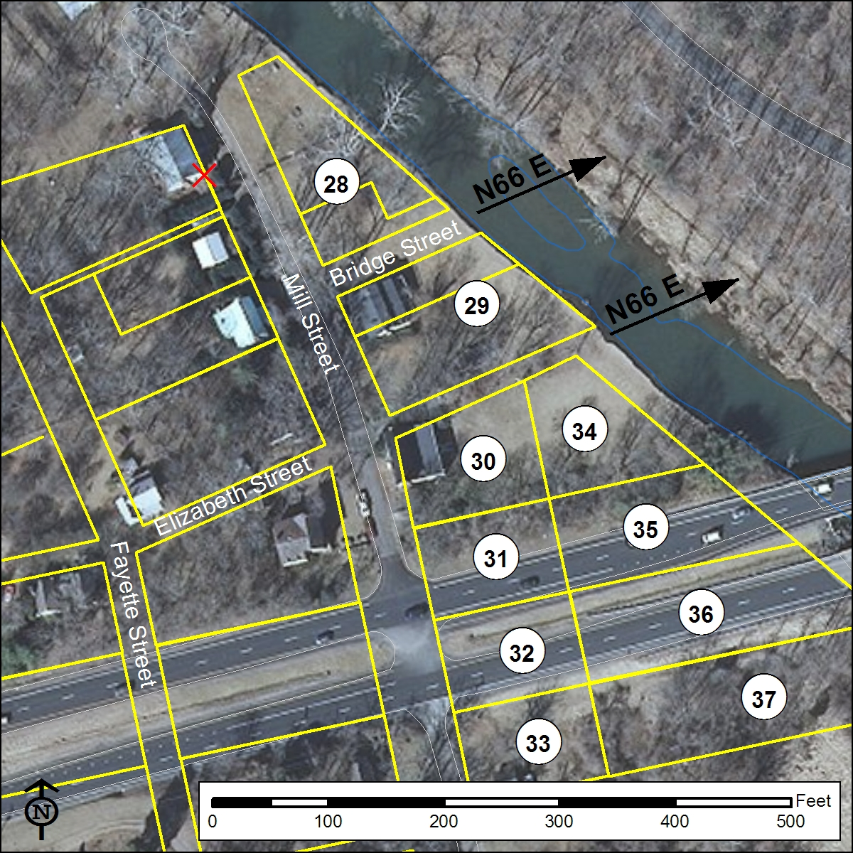

Figure 110: GIS map showing a preferred reconstruction of the original boundaries of Lots 28 – 37 overlaid on recent aerial photography. Note reorientation of Bridge Street and the continuation of Elizabeth Street between Lots 29 and 30/34.

East of Broad Run (Lots 38 – 48)
Existing reconstructions of the Buckland town plan locate 11 lots (Nos. 38-48) east of Broad Run, situated along Love, Bridge, Jefferson, and Washington Streets. Ample evidence exists in deeds to indicate that both Love and Bridge Streets crossed the stream and intersected with Jefferson Street and Washington Street on the eastern side of Broad Run. However, only Lots 38, 47, and 48 can be confidently placed east of Broad Run on the basis of descriptions provided in deeds. Logical conjecture strongly suggests that the remaining lots (Nos. 39-46) were also platted east of the stream however no information exists regarding their size or placement relative to one another and the street grid. Further compounding accurate reconstruction of the original town plan is the fact that no compass bearings are provided for lot or street lines east of Broad Run.

Lot 38: Lot 38 was among the group of 11 lots not sold by the trustees of Buckland in July 1798 because it had been “built on previous to the law which passed for establishing the town.” In June 1799 John Love conveyed Lot 38 to George Britton. Britton paid taxes on the property until at least 1804. The deed recording Britton’s purchase of the property describes Lot 38 as being bounded by Broad Run to the west, by Bridge Street to the south, and by Jefferson and Love Streets to the east and north, respectively. The Broad Run and Jefferson Street sides both measure 190 ft while the Love Street and Bridge Street sides are each 113 ft in length, however compass bearings for the sides of the lot are not provided. Beginning in 1810, land tax records indicate that Lot 38 was owned by Samuel King, a free man of color. King dies around 1822 and the following year the property is attributed to his estate in County tax records. From 1851 through 1877, land tax records list King’s widow, Celia King, as the owner of Lot 38. During the entirety of the Kings’ ownership of Lot 38, tax records indicate a building on the property. The orientation Lot 38 and of adjacent Bridge and Jefferson Streets shown in Figure 111 is based upon an 1841 metes and bounds description of the property now known as Cerro Gordo. As shown in Figure 111, the 1841 Cerro Gordo property line followed an unnamed road southward towards Broad Run to “a point in the Road at the Corner of old Celia King’s lot,” whereupon the line turned southeast and ran to “the corner of an old barn House.” When rotated to account for historic variation in magnetic declination (0.67º counterclockwise), the Cerro Gordo property lines indicate an orientation of S49º East for Jefferson Street and N41º East for Bridge Street east of Broad Run.

Lots 47 and 48: According to the July 7, 1789 list, Lots 47 and 48 were sold together by the Buckland trustees to George Britton and a separate deed recording the conveyance was entered one week later describing the two lots as being located within “the square formed by Washington, Bridge, Jefferson, and Love Streets. The northwestern corner of the two-lot block is further provided as the intersection of Washington and Love Streets. Measurements of all four sides of the block record an irregularly-shaped parcel:
about 270 ft along Love Street;
about 187 ft along Jefferson Street;
about 250 ft along Bridge Street; and
about 200 ft along Washington Street.
Possibly, the variation in measurements between four the sides of this block, consistently described as apparent estimates in the deed, reflects the relatively pronounced steepness of the terrain on this side of Broad Run and the difficulty of calculating distances accurately. In the reconstruction presented in Figure 111, the orientation of Lots 47 and 48 follows that established for Lot 38 on the basis of the above-mentioned 1841 metes and bounds description of the lines of the Cerro Gordo property. The combined Lot 47-48 frontage along Jefferson Street and Washington Street in the reconstruction is 190 ft, the same value as Lot 38’s frontage on the opposite side of Jefferson and close the provided measurement of “about 187 feet” for this side of the two-lot block. In Figure 111, 270 ft has been used for the lots’ frontages on Love and Bridge Streets, which results in a 30-ft width for Washington Street if the platting of the 1796 boundary between the lands of John Love and George G. Tyler shown in Figure 111 is accurate. Using the alternate measure of 250 ft for the long sides of Lots 47 and 48 would result in a roughly 50-ft width for Washington Street.

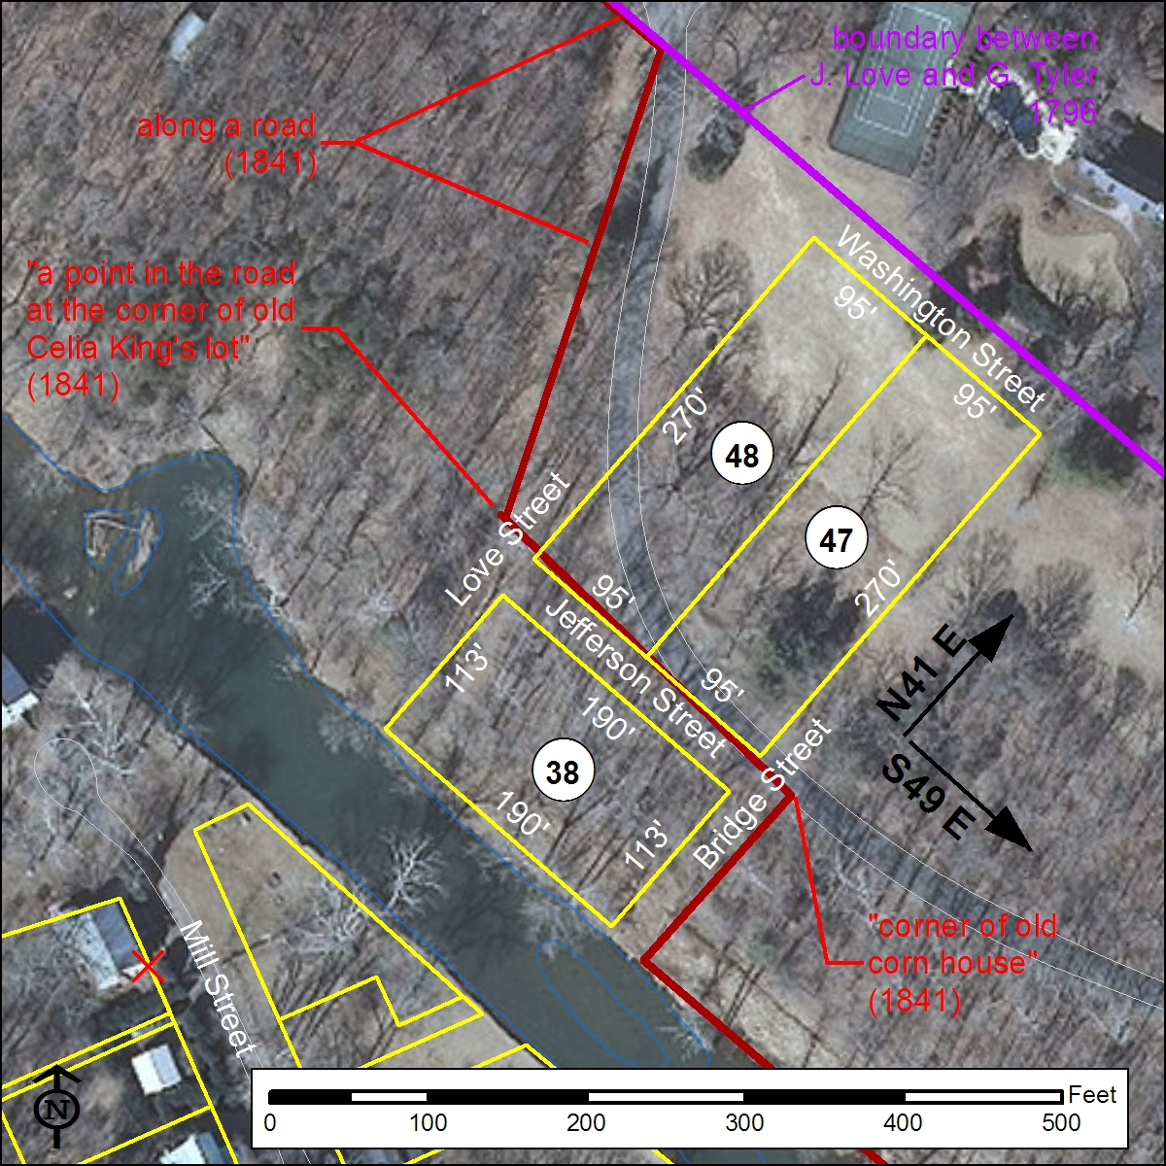

Figure 111: GIS map showing the proposed boundaries of Lots 38, 47, and 48 east of Broad Run as reconstructed from late 19th- mid-20th-century lot descriptions and overlaid on recent aerial photography. Orientation of the lots relies upon late 18th and 19th-century metes and bounds descriptions of the neighboring Cerro Gordo property.

Lots 39 – 46: According to the July 7, 1798 list of lots sold by the trustees of Buckland, John Love purchased Lots 39, 40, 41, 42, 43, 44, and 46. As mentioned, it is possible that Lot 45 was intended here rather than Lot 46, as the latter is also included in the accompanying list of 11 lots not sold due to their having already been built on prior to the town’s establishment. Lots 39, 40, 41, 42, 43, 44, and 46 (again, Lot 45 is not mentioned) were all among the large group of Buckland properties mortgaged by John Love in 1800 to John Taylor, Joshiah Watson, and William Brooks. No description of any of these lots has been discovered and their history after 1800 is unknown. Based on the clear location of lower numbered (Lot 38) and higher numbered lots (Lots 47, 48) east of Broad Run, it can be assumed that each of these eight lots also was located east of the stream. The reconstruction presented in Figure 112 uses a logical pattern to locate the remaining eight lots. Lot depths (southwest-northeast) of these eight lots are based upon the straight-line extension of Washington and Jefferson Streets southeastward. Lot widths (northwest-southeast) are based upon the 95-ft half-block standard used in the reconstruction of Lots 38, 47, and 48). Thus, Lots 39 and 40 located between Broad Run and Jefferson Street both measure 113 ft by 285 ft (95 ft x 3) while the six lots (Nos. 41 – 46) on the opposite side of Jefferson Street each measure 270 ft x 95 ft. While the “old corn house” referenced in the 1841 metes and bounds description of the Cerro Gordo may have stood within Celia King’s Lot 38, given that Lot 46 may have been built on prior to the establishment of Buckland it is possible that the “corn house” stood in the southwest corner of Lot 46.
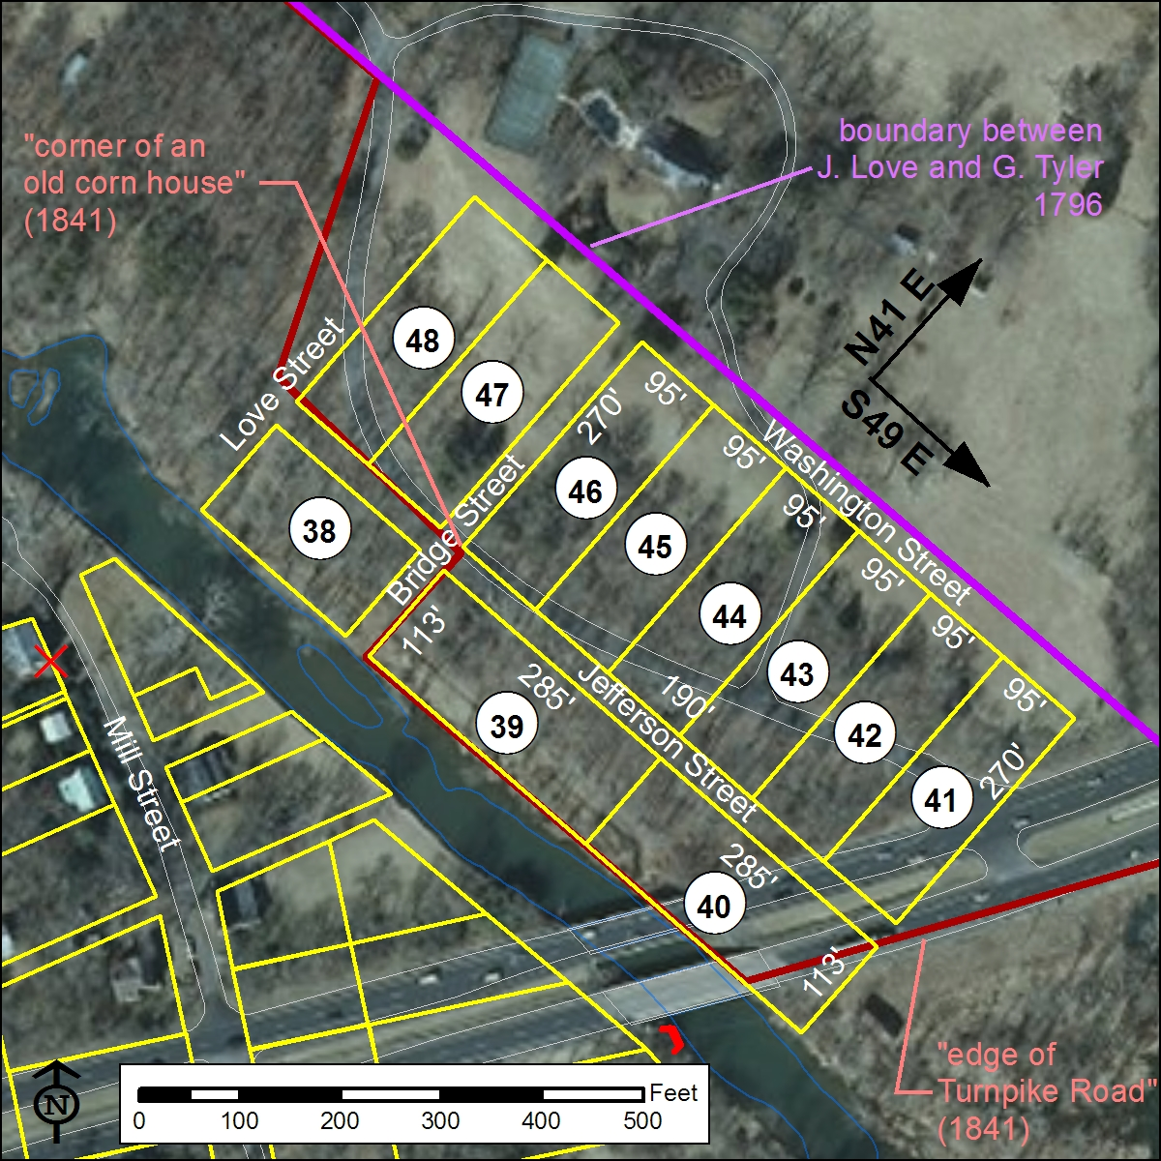

Figure 112: GIS map showing the proposed boundaries of Lots 39 - 46 east of Broad Run. Orientation of lots relies upon late 18th and 19th-century metes and bounds descriptions of the neighboring Cerro Gordo property.

The Fauquier & Alexandria Turnpike Road
Reconstruction of the route of the Fauquier and Alexandria Turnpike utilizes the placement of the extant stone bridge abutment on the west bank of Broad Run (mapped by submeter accuracy GPS in 2012 by RAS) as well as a series of nineteenth-century metes and bounds surveys of properties adjoining the road. A width of 50 ft for the turnpike is provided by G. W. Norris’s 1855 survey of Buckland Farm for Temple M. Washington, in which the farm’s property line runs along the road “twenty-five feet from the center of the [turnpike’s] pavement.” The extant bridge abutment measures 20 ft in width, indicating that the turnpike reduced to roughly half its width to cross Broad Run. As detailed in Figure 113, construction of the turnpike in 1812 would have taken roughly half of Lots 36, 32, 5, and 14, as well as smaller fractions of Lots 37, 33, 6, 15, 23, 24, and 40.

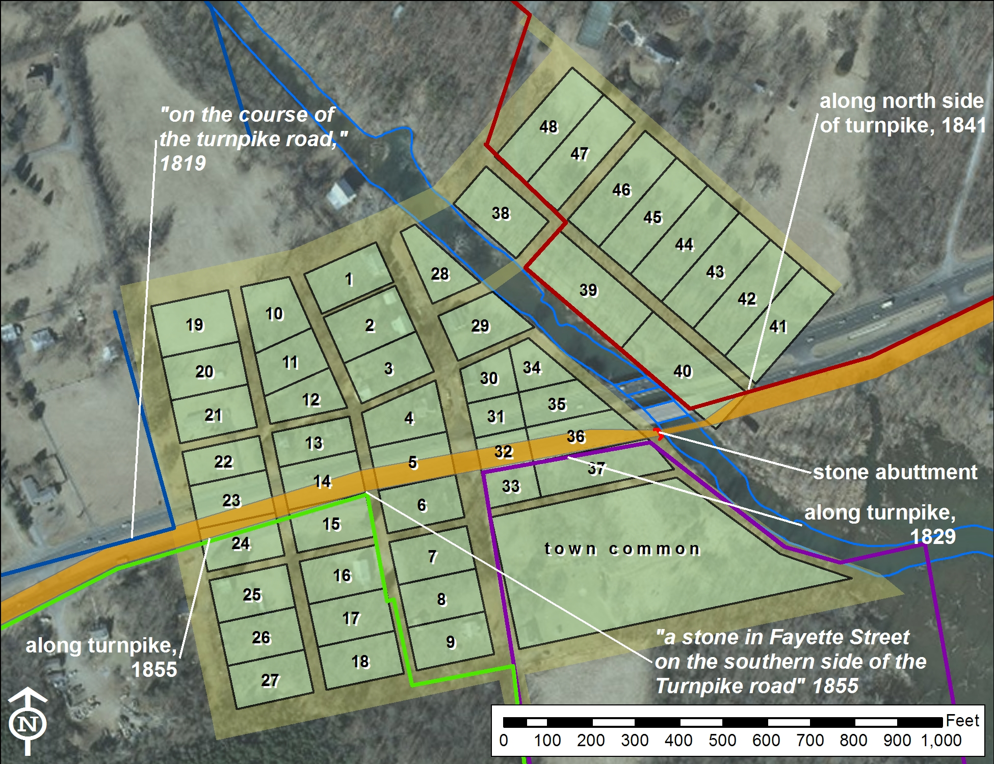

Figure 113: GIS map showing the reconstructed Buckland town plan and the route of the Fauquier and Alexandria Turnpike as determined from historic metes and bounds surveys and the extant western bridge abutment at Broad Run overlaid on recent aerial photography.

Petition to establish the town of Buckland, December 8, 1797. General Assembly Legislative Petitions, 1776-1865, Prince William County, Box 210, Folder 52, Library of Virginia; cited in Blake and Fonzo 2005:6, note 6.
“An Act to Establish Several Towns,” January 15, 1798. Virginia General Assembly Session Laws, 1794-1812, Chapter LXIX (1798), p. 33, Library of Virginia; PWCDB 4:431.
According to the list of lots and their buyers, Lot 46 was purchased by John Love although no price was recorded, while Lot 45 is not included in either list. It is unclear which of these two lots was sold to Love and which was not sold by the trustees as it had been developed prior to the establishment of Buckland.
An approximate date of this reconstruction around the onset of the 20th century is based upon property owners included on the sketch map.
Ridout et al., Entrepreneurial Landscape, p34-40.
U. S. Department of Commerce, National Oceanic and Atmospheric Administration, National Geophysical Data Center. Historic Declination Calculator. http://www.ngdc.noaa.gov/geomag-web/#ushistoric.
PWCDB Z:58; Z:466.
PWCDB Z:70; Ridout et al., Entrepreneurial Landscape, p55-61.
PWCDB 1:9; B:391.
PWCDB Z:530; 2:520; Z:471; Ridout et al., Entrepreneurial Landscape, p55.
PWCDB Z:471.
PWCDB 2:533.
PWCDB 2:386; 1:248; Ridout et al. Entrepreneurial Landscape, p89-90.
PWCDB 2:27; 23:185; 26:26.
PWCDB 2:385; 1:156; 2:24; 2:385.
PWCDB 1:159.
PWCDB 10:414; 23:435.
PWCDB 24:63.
PWCDB 24:63.
PWCDB 44:199 records the conveyance of a 52.64-acre “part of the Buckland Mills Tract” by the estate of Ross Campbell to James T. Utterback. The metes and bounds description starts at a corner of “Patties Lot” and the turnpike. Platting of the survey clearly places this point along the west side of Lot 23 (see below), indicating that Oscar Pattie owned Lot 23 in addition to Lot 14 on the opposite (east) side of Madison Street (see above).
PWCDB 2:385; 7:124; 44:199.
PWCDB B:391; 1:10; 1:208; 4:346; 52:140; 41:199.
This southern portion of Lot 29 containing a “stone still house” was among the Buckland lots that John Love mortgaged to John Taylor, William Brooks, and Josiah Watson in 1800 to secure debts (PWCDB 1:208). In the subsequent agreement between Love and Josiah Watson dividing these properties between them (PWCDB 4:346), it would appear that Love retained ownership of this southern, “still house” part of Lot 29 while Watson acquired the northern part of neighboring Lot 28.
PWCDB Z:413; 1:156; 4:434; 4:436; 28:10; 41:199; Ridout et al., Entrepreneurial Landscape, p12; Laird and Fesler, Archaeological Testing and Survey of the Buckland Mills and Distillery Properties, p24.
PWCDB 4:431; 1:208; 11:445; 13:158; 25:109; 30:365; 30:415; 230:202.
PWCDB 4:431; 1:158.
PWCDB 4:431; Z:531; 7:194; 26:244; 30:338; 38:438; PWC Loose Papers, Box 6.
PWCDB 4:431; Z:531; 4:346; 12:46.
PWCDB 4:431.
PWCDB 4:431; 7:529; 2:68; 10:194.
PWCDB 4:431; 12:46.
PWCDB 4:431; 2:527; 6:240.
PWCDB 4:431; 2:29.
PWCDB 4:431; 1:208; 6:240.
PWCDB 26:26.

